Data Sharing in a Pandemic Citizens’ Juries
Jury 1 of 3 (England) - March 2021
Jurors’ Report

A report produced with the 17 members of the jury of adults from across England assessing the future of data sharing initiatives introduced in response to the Covid-19 pandemic
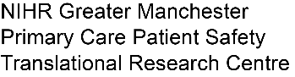
March 26 2021

Commissioned by: and NHSX

Designed and delivered by:

Table of Contents

Preface 3
About this report 3
1. Statements to Commissioning Bodies, Policymakers and Public 4
2. The jury questions and the jury’s answers 9
2.1 Data Sharing Initiative: Summary Care Record Additional Information 9
Q1 How supportive are you of the decision to introduce this data sharing initiative in 2020 as part of tackling the COVID-19 outbreak? 10
Q2 What should the future of the data sharing initiative be? 11
2.2 Data Sharing Initiative: NHS Covid-19 Data Store and Platform 14
Q1 How supportive are you of the decision to introduce this data sharing initiative in 2020 as part of tackling the COVID-19 outbreak? 14
Q2 What should the future of the data sharing initiative be? 16
2.3 Data Sharing Initiative: Early Warning System 19
Q1a How supportive are you of the decision to introduce this data sharing initiative in 2020 as part of tackling the COVID-19 outbreak? 19
Q2a: For how long should the initiative continue? 19
2.4 Data Sharing Initiative: Immunisation and Vaccination Management Capability 20
Q1a How supportive are you of the decision to introduce this data sharing initiative in 2020 as part of tackling the COVID-19 outbreak? 20
Q2a: For how long should the initiative continue? 20
2.5 Data Sharing Initiative: OpenSAFELY and its access to GP data 20
Q1 How supportive are you of the decision to introduce this data sharing initiative in 2020 as part of tackling the COVID-19 outbreak? 21
Q2 What should the future of the data sharing initiative be? 23
Q3 What lessons could be learned for the future? 26
3. The jury process: what we heard and did 28
Jury Day 1: Context setting 28
Jury Day 2: Background information 28
Jury Day 3: Summary Care Record Additional Information 30
Jury Day 4: NHS Covid-19 Data Store and Platform 31
Jury Day 5: Early Warning System and Immunisation and Vaccination Management Capability 33
Jury Day 6: OpenSAFELY 33
Jury Day 7: Jury Deliberations 34
Jury Day 8: Deliberation and report writing (this report) 35
Appendix A: The jury questions 36

Preface

About this report

This is a report from the 17 members of the citizens’ jury who met online over eight afternoons between 16 and 25 March 2021 to hear evidence from a wide variety of witnesses, to deliberate together, and to make recommendations. 18 jury members drawn from a cross-section of adults across England were recruited; unfortunately one person had to withdraw from the jury after day three for personal reasons. It is the first of a set of three citizens’ juries on data sharing in a pandemic commissioned by the University of Manchester (with funding from the National Institute for Health Research Applied Research Collaborative), NHSX (part of NHS England and NHS Improvement), and the NHS National Data Guardian’s Office. The second and third juries being held in April and May have juries drawn from Greater Manchester residents and Sussex residents respectively.
The report was constructed using the words of the 17 jury members, using statements they prepared together. A draft version was reviewed and agreed by jury members as part of the jury process on 25 March before being reformatted, distributed to members of the jury, and published online.
A Juries’ Report about all three juries with additional information (e.g. on jury recruitment) will be produced by Citizens Juries c.i.c. and published online in June 2021. Other materials including presenters’ slides will also be published online after the three juries.

Statements to Commissioning Bodies, Policymakers and Public

At the conclusion of the jury, participants chose to share the following about their experience and collective work assessing the pandemic data sharing initiatives and their future:

Statement to Neighbours

What is important for your family, friends, or neighbours to know about your experience with the jury and your peers during the past two weeks?
You will probably begin not realising how little you know about what you're discussing and you'll gain a lot of knowledge from both the other members of the jury and those presenting. Time goes by quickly - especially in the last two days.
The whole process was interesting and the subject covered was very thought-provoking. It was great to 'meet' and chat to so many different people with the opportunity to discuss something worthwhile that affects pretty much everyone in England.
The jury was very informative and insightful considering it was only brief. It was nice to gain perspectives and work with others that I would not normally interact with on a daily basis.
It’s important for others to know that there are no data experts amongst jury members, but that everyone brings different skills, understandings and views; all are valid and all are of relevance. As 'Jo Public,' there are often more similarities than there are differences.
I have learnt that sharing experiences and views with the jury has had a positive impact on how others look at the different aspects of collectively making decisions. It has been a knowledgeable and positive experience that I can take away with me, knowing that our views have possibly had an impact on decision making in the future post-pandemic.
This has been a very informative and interesting process. When I saw the binder of information that we were sent it looked overwhelming, but the way the Jury has been done has allowed time to reflect, absorb and consider. Kyle and Sarah have done a great job of keeping the process running smoothly. I would fully encourage anyone to take part as it is eye-opening and challenges you to think outside of your own thoughts.
What a fantastic experience to be a part of. This jury and its experts have been really well put together. It has been incredibly insightful and I have learned a lot from it. It has opened my mind to learning more about data sharing and going forward I will certainly be reading more about it. It has been great to hear the opinions of the other jurors which has helped me to have a different outlook on my own opinion. Great job and thanks for letting me be a part of it.
It is a highly interesting and engaging experience, which makes you far more aware of current events, the majority of which I certainly was not previously aware of. It makes you consider the topic far more outside the jury, particularly how it affects you as an individual and the country as a whole. In the past few days it has been interesting to see how much my family and friends know about the initiatives and their opinions on them. It also allows you to learn and review with a range of people from different occupations and backgrounds who all have very different views on the topics looked at within the jury.
The process is intense but very enjoyable, with a lovely group of people from all over England. I've learnt a lot about data and how it has been used throughout the NHS during covid and how it could and should be used in the future, which is not something I've really considered before. The presentations have been interesting and insightful and very useful in informing my decisions, along with the views of my fellow jurors. I've really liked being part of the jury and would recommend to anyone.
The Citizens' Jury is an extremely interesting experience which I would highly recommend anyone undertake if they get the opportunity. The process is run such a way that it makes it almost impossible for anyone not to feel a valued part of the jury. It also gives you an exceptional insight into a particular issue which causes you to think outside your normal way of thinking, and to question how decisions are made for us. Above all, it is thoroughly enjoyable and there is never a dull moment!
It's important for everyone to know that the citizens jury facilitators and my peers have made me feel like my opinion counts and is heard. This has made the experience an enjoyable one.
Being on the jury was, for me, an opportunity to build my own opinion through experts' presentations, taking into consideration all of the others' points of view. It led me to think about a lot of subjects and has opened my curiosity.
It is possible to discuss problems from different perspectives and arrive at answers that include different views. And it's worth 'taking part' rather than just 'letting them' do the talking and make decisions. If nothing else, it at least removes distrust that may now and then accidentally creep between us. Yes, I enjoyed working on the jury. It gave me an opportunity to 'give something' but also it helped me clarify several points that hitherto seemed to be outside my own ability to clarify. Thank you, all.
For me, it is making them aware of how and where their data is being used and that they have the option to opt-out after doing some of their own research to the initiatives.
We listened to some very intelligent speakers who were all very professional in sharing their expertise. Some topics were very interesting but then a decision I had would be swayed quite easily with the next topic and made me more open to debate. The fellow Jurors were lovely people and it was obvious everyone was hooked and had an interest with each activity. I'd say a high volume of conclusions we all had were very similar and all questions asked from the group were noted from the speakers as being valuable. Being broken into smaller groups helped each Juror get more involved in the discussion. There was no squabbling or negative input throughout. I thought Kyle, Sarah and Malcolm put on a great show!
During my time on this Citizens’ Jury I have learned and discovered that we have the right to have an enhanced NHS summary care record and that we have the right to opt out of this data being shared without our consent. I have now found that COPI regulations issued under the emergency powers granted in response to Covid-19 pandemic have overridden this right and that patient records have been copied from their original location (GPs) and have been located on various platforms this data has been used by the NHS and commercial companies to provide statistical and logistical data to aid the NHS responses to the Covid-19 pandemic. It was also intimated that some of this data has also been used for purposes other than Covid-19. This has been done with all data held without regard for persons who have already exercised their right not to share their data and that this has not been widely publicised.
It was really interesting on what has been happening in the background with Covid-19, the NHS, governing bodies, Parliament, etc. My friends and neighbours have no idea! If I did not attend this Jury I would not know of the data sharing initiatives and the solutions (Data Store and Platform, OpenSAFELY, SCR, EWS and IVMC) that were put in place due to the pandemic, and in such a short time. I was surprised at the lack of transparency regarding the public knowing about this work. I have really enjoyed listing and discussing with all the groups and hearing all their views. Whether you agree with them or not, it was really interesting. The delivery of how this Jury was presented was brilliant. The process and how it flowed was brilliant. I have loved every minute of the past eight days and will miss it tomorrow.

Statement to Commissioners and the Public

What is important for those involved in the Pandemic Data Sharing Initiatives and the public to know about the work that you’ve done together as a jury over the past two weeks?
I think it's important to know that the work we have done as a Jury has not been taken lightly. We have fully engaged with the process and taken time to properly consider each initiative we have been informed of. I have tried to remain open minded to every presentation and have listened carefully to my fellow jurors’ thoughts, which have highlighted points that had not necessarily occurred to me. I don't believe that there have been any negative outcomes from this process, only future considerations and learning points. I hope that our views are taken into consideration as members of the public who have been lucky enough to be given insight to these initiatives.
Transparency is really important to most people. Being as open, honest and informative as possible in decisions that affect the public should be seen as being vital.
It is important to have things made clear to the public about what has changed because of Covid, how the data is used and by whom, how this affects the public, and to make this accessible to different groups so they are aware and know that they can opt-out.
It is important that those involved in the Pandemic Data Sharing Initiatives, including NHS Governing Bodies, are aware that the public, including those on this jury, have views. Wider efforts must be made to ensure the public are informed and have a voice. The use of a 'citizen jury initiative' could usefully be rolled out on a greater scale for wider public consultation, and for diverse issues, thereby aiding increased societal involvement to feed back to various governing or governmental bodies.
It's important that everyone knows that the data sharing initiatives have been presented to us in a balanced way in order for us to make our decisions.
We have taken time to be deliberate to arrive at the best possible outcome after listening intently to all the information that has been given by the presenters. Some of the highly-knowledgeable information that was shared I would never have even have known or understood previously if I had not been involved in the citizens jury. Now understanding what has been going on with regards to public data before and throughout the pandemic, this process has definitely been an eye-opener.
It's important for governing bodies to know what we the jurors have taken on board during these eight days and how we have collectively come together to share how we feel about the current data sharing initiatives and to what ends they can be used in the future. It's also important for governing bodies to know that they need to undertake more public outreach on these matters as I'm sure a lot of people are blind to this as I was before this jury.
This Citizens' Jury has been given an exceptional insight into some of the data sharing initiatives which have been instigated to inform the NHS and government response to the Covid-19 pandemic. It is clear from the deliberations that the public has worryingly little insight into the way in which our medical data is stored, shared, and used. It is also clear that it takes a long time for a member of the public to fully understand and appreciate the implications of what has taken place and will take place in the future.
It is important that people are aware of how their data is used and what their options are for its use, such as being able to opt out of its inclusion in initiatives. While I appreciate all the wonderful work the NHS does and how it has coped during the pandemic, the governing bodies need to be far more transparent with the public and let them know why and where their data is being used. There is a great pool of legal expertise out there and there should be no excuse for not being lawful, fair and transparent with the public.
It is always of public interest if someone starts to ask "why" about the reality.
We do care about what you do for us and/or on our behalf. We want to trust you and we want you to trust us. 'Emergency' ends when we stop distrusting each other.
It is important for the public to firstly be made more aware of the initiatives, as the common theme through the jury has been the clear lack of transparency. If the more of the public knew about the initiatives then this would build a lot more trust and show how the conclusions we have come to as a jury reflect the opinions of the wider public.
It is important for the public to be made aware of data sharing and the ability to opt in or out. It is also important for the public to know that their personal records are safe and secure and not shared for commercial reasons. It is important that the Governing Bodies have worked with the Parliament and have agreed on a decision regarding what happens post-COVID with the data sharing initiatives in order to ensure all legal frameworks are in place.
I think all the initiatives should be fully addressed by an Independent Advisory group of experts and the government. Everything we discussed in these juries needs to be out in the open so the general public are made aware about how and where their data is used and what happens going forward into the future.
We have discovered that data sharing at present is still in its early stages and still needs tweaking. Most Jurors were broadly supportive of the different initiatives but each time we discovered a lot of negativity especially with transparency from how data is collected and what opt-out rights that you have. Two out of the three data initiatives are in need of catch up and could learn from the other. Being clear to the public and not holding back data would give more confidence going forwards from all initiatives.
It is important to know and share that the jury has heard from many experts during this time. They have all expressed reasons and concerns regarding a number of data sharing initiatives, and the jury has sat and deliberated on these taking into consideration the issues for their introduction regarding the Covid-19 response, the security and use of patient data and the right to opt-out. We have made and agreed upon recommendations collectively, including how we broadly believe this information should or could be used going forward whilst still respecting individuals’ rights.
Those involved in the Pandemic Data Sharing Initiatives should know their presentations have been discussed and disseminated at great length by this Jury and that, hopefully, as a result of this process greater efforts will be made to ensure that the public is made aware of how their personal data is used and for what purposes.

The jury questions and the jury’s answers

The questions for the citizens’ jury, and our answers/recommendations are set out below. The jury questions are in italics. Our answers explain, in our own words, what we thought about the pandemic data initiatives we considered. We voted to prioritise what we considered to be most important of our ideas, and the numbers of votes are shown throughout section 2 (often votes exceed 17 in total because we were given more than one vote each).
This section begins with jury questions (see Appendix A) and answers about the jury’s three pandemic data sharing initiative case studies, and two sub-case studies (both of which are products within the NHS Covid-19 Data Store and Platform):
- Summary Care Record additional information
- NHS Covid-19 Data Store and Platform
  - Early Warning System sub-case study
  - The Immunisation and Vaccination Management Capability sub-case study
  - OpenSAFELY and its access to GP data
We had fewer questions to answer about the two sub-case studies and consequently less time to consider them (half a day each).
At the end of this section of the report are our answers to further questions about lessons learned for future pandemics.
The process we went through to reach our conclusions is described in section 3.

Data Sharing Initiative: Summary Care Record Additional Information

The data initiative being considered here is the extraction of “additional information” from over 50 million computerised patient records held in general practices’ (GPs’) computer records into the Summary Care Records for those patients held on the national “Spine”. The Summary Care Record is used to view information (including the additional information) about a patient by those providing care. Prior to the pandemic this additional information was only uploaded into a patient’s Summary Care Record with the patient’s express consent. In Spring 2020 the data from GP records was added without asking patients in order to assist with patient care during the pandemic. The initiative was a direct response to a direction within the COPI Notices issued in 2020 (subsequently renewed until September 2021).

Question 1 asks how supportive we are of the decision to introduce the data sharing initiative in Spring 2020. We voted on the multiple choice question (Q1a).

Q1 How supportive are you of the decision to introduce this data sharing initiative in 2020 as part of tackling the COVID-19 outbreak?

Answer choices | Responses | Percentage
Very much in support | 7 | 41%
Broadly supportive | 10 | 59%
Neutral | 0 | 0%
Broadly opposed | 0 | 0%
Very much opposed | 0 | 0%
TOTAL | 17 | 100%

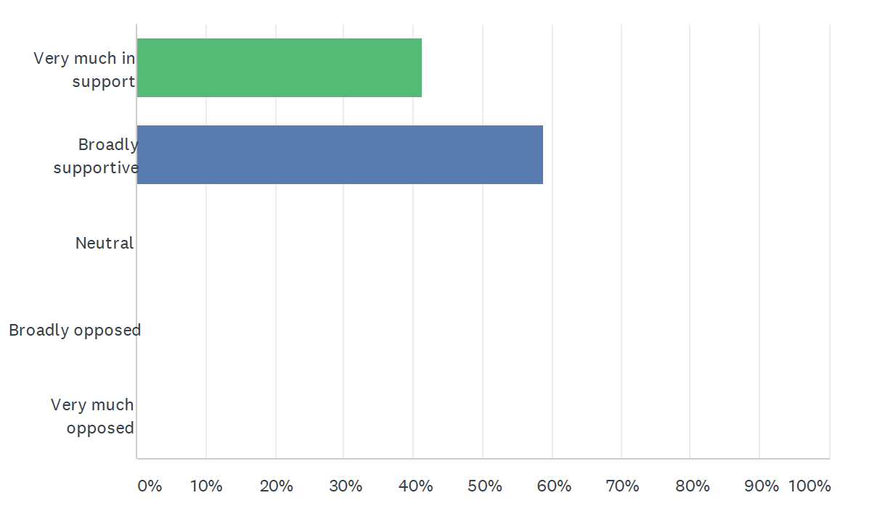
We also identified and prioritised our reasons to support (Q1b) and oppose (Q1c) the data sharing initiative.

Reasons to Support - Summary Care Record (Additional Information)
The SCR with additional information gives a broader range of healthcare professionals timely access to useful information which allows them to treat patients in a more time-effective way, give better care, and potentially save lives (such as in emergency situations, A&E, etc.,) in a range of settings. - 16 votes
Using enhanced SCRs with additional information can improve future research and planning of care delivery for patients and save more lives in the future (such as in planning for future pandemics). - 13 votes
Different medical care departments/facilities can access the information without relying on the patient for their past medical history, which may be difficult for some people (eg if they are incapacitated or can’t communicate for other reasons). - 10 votes
Future enhanced SCRs with additional information may be on legal footing, with necessary safeguards, which could comply with laws, build trust among the public, and make them more effective. - 9 votes
This initiative will help the current drive to improve electronic health records (which patients can ultimately opt in or out of sharing). - 2 votes

Reasons to Oppose - Summary Care Record (Additional Information)
There is a lack of transparency and public awareness around the SCR additional information, that it exists, what it contains, who has access to it, how the changes affect what can be seen, and that patients are able to opt out if they desire. - 14 votes
Concerns around the overall security of the records, the number and types of access/entry points, the risk of the information being accessed by hackers or unauthorised parties, and unclear checks and balances for the initiative. - 11 votes
People are not fully informed about their ability to opt out of this initiative and there was not a blanket informed consent required to create the enhanced records (additional information) during the pandemic. - 9 votes
The lack of data safety reassurance and ability to know why and who is viewing the SCR’s (and for what purposes) if patients haven’t been informed beforehand. - 8 votes
Only 25% of enhanced SCR records have been used so the benefits are unclear while it is difficult to know what types of information or data has been used. - 4 votes
The emergency powers [enhanced data collection] and the retention of additional information data within existing SCRs, and newly created patient SCRs generated by COPI, may continue without informed consent of the individual patient - particularly when many patients were not informed on the initial pre-covid SCR, let alone the right to opt out. - 3 votes
The lack of awareness around how vulnerable groups and those incapable of making an informed decision, even with the availability of clear information, would be taken into account. - 1 vote

Q2 What should the future of the data sharing initiative be?

We heard arguments from witnesses and then voted on two multiple choice questions about what we believe should be the future of the Summary Care Record Additional Information data sharing initiative. The witness speaking in support of the initiative argued that the initiative should continue for as long as it is valuable, and that the decision should be made by the organisation accountable for the initiative (informed by patients and other stakeholders). We heard from the challenge witness (Phil Booth from medConfidential) that the initiative should only continue as long as the pandemic continues, and that the decision should be made by an independent advisory group of experts and lay people.

Q2a: For how long should the initiative continue?

Answer choices | Responses | Percentage
As short a time as possible | 0 | 0%
Only as long as the Covid pandemic continues and emergency powers are in place | 1 | 8%
As long as it is valuable (potentially beyond the pandemic and for Covid and non-Covid uses) | 16 | 94%
Something else | 0 | 0%
TOTAL | 17 | 100%

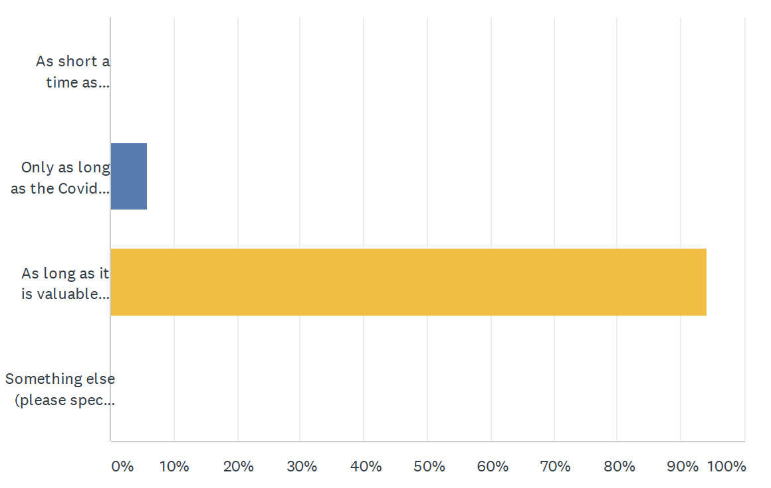

When voting on this question in the online questionnaire, we were each asked to give a brief reason for our answer. Reasons will be analysed and reported in the Juries’ Report in June.

Q2b: By whom should these decisions be made?

Answer choices | Responses | Percentage
An independent advisory group of experts and lay people | 6 | 35%
The minister or organisation accountable for the data initiative | 0 | 0%
Parliament | 9 | 53%
Someone else | 2 | 12%
TOTAL | 17 | 100%

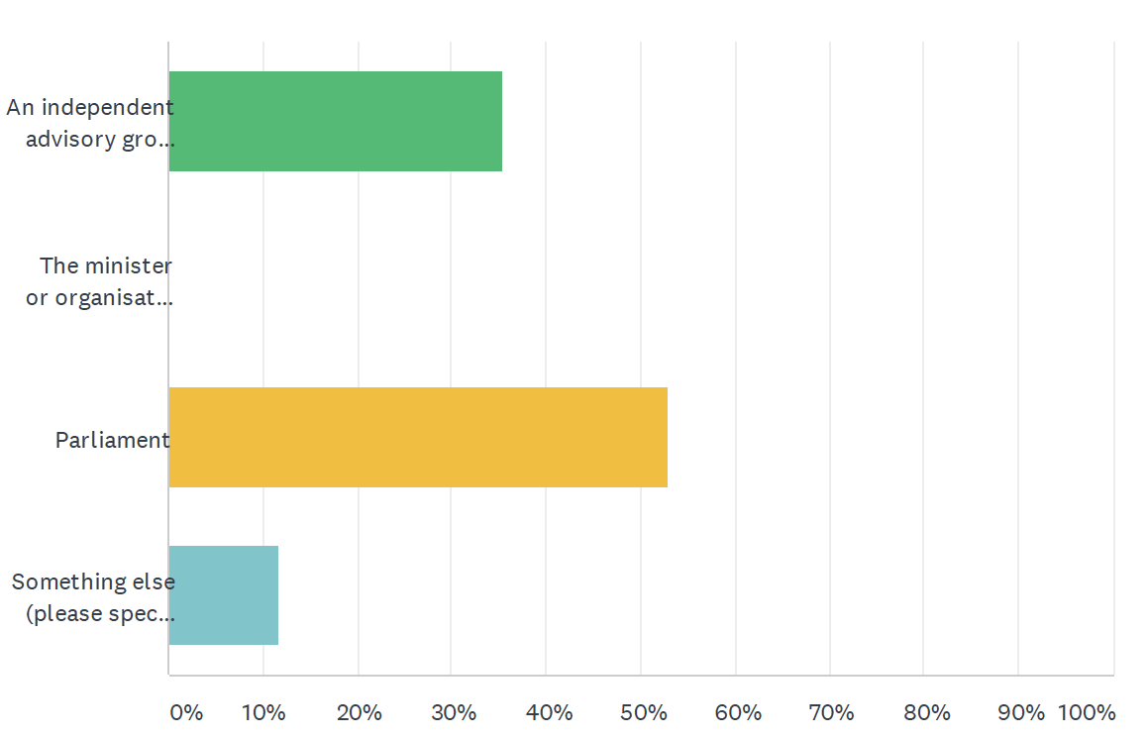

When voting on this question in the online questionnaire, we were each asked to give a brief reason for our answer. Reasons will be analysed and reported in the Juries’ Report in June.

We were also asked two further questions about the future of the data sharing initiative:
- What actions, if any, could be taken to engender greater public trust in the initiative? (Q2c)
- How could or should the initiative and its uses be usefully changed in the future (if at all)? (Q2d)
We worked together in groups to identify and prioritise our answers and reasoning to these questions. Our answers and most important reasons for those answers are set out in the two tables below.

Summary Care Record Additional Information - Future Changes
This initiative may be usefully improved by continuing to permit specific anonymised data to be used as a planning and procurement tool provided that access is strictly controlled and scrutinised when data is requested and again prior to it being released back to the requestor and it must allow a clear transparent audit path that is available publicly.
This initiative may be more useful in the future if communication to the public more effectively made patients aware that they have an option to opt out of the additional information.
A useful change to this initiative would be to keep it as Opt Out regarding additional information (rather than Opt In as it was prior to the pandemic). This would be very useful for healthcare professionals but would also have to be heavily advertised through the media and the patient’s GP.
The initiative could be improved in the future through the increased use of data usage reports which would build up more trust between patients and the NHS.
An important useful change that could be made to the initiative in the future is to improve communication with the public in order to ensure they are more aware of the initiative, build trust, and increase transparency. This could possibly be done by sending out emails or letters, via the NHS website, and other communications methods.
It is essential that information is provided in clear accessible language (non-specialised) and local community languages so all patients and the public are able to make an informed decision about their data usage and/or right to opt out.
The COPI notice that is currently in use expires in September 2021. Before this expires a new legal, parliamentary framework will need to be established to continue with the enhanced SCR.

Summary Care Record Additional Information - Engender Public Trust
Providing clear audit trails of requestors of information and their reasons for requiring patient health record data whether it be for analysis’ commercial gain or other reason, would engender public trust. These requests must be lawfully justified and available to the public. Should a requestor ask that results are withheld from the public these reasons shall be clearly stated in the public domain. A method of broadly advising the general public that data is being used should be implemented to inform them and to ensure that GP’s are protected from unintentional misuse and release.
Public trust could be built by introducing Data Usage Reports, so people can see when and where their report was accessed. NHS England should also work more closely with groups like Med Confidential to check everything is lawful, fair and transparent.
Greater public trust could be gained through increasing communication via mediums with which the public have regular contact. This would take into account what media the majority of the public consume and engage with on a regular basis (e.g. social media [Facebook, etc], ITV and online media as opposed to just the BBC). Information could also be disseminated through GP surgeries and more local newsletters and not just on NHS websites or ‘broadsheet’ media. Using these communications channels would increase overall transparency.
It may be useful to have a public review of what was done during the pandemic, what worked, what didn’t, etc., and this could be followed by a public consultation on the use of public data, enhanced SCR’s, opting out and use of data in emergencies.

Data Sharing Initiative: NHS Covid-19 Data Store and Platform

The data initiative being considered here is The Covid-19 NHS Data Store and Platform "ecosystem", including all the data flowing in and being processed by the Data Platform and associated products, and all the data flowing out. Patient-level and aggregated data flows into the Data Store and is de-identified and held within the Data Platform for use by many different products being used to tackle the pandemic. The products include the Early Warning System and Immunisation and Vaccination Management Capability sub-case studies (see sections 2.3 and 2.4 below). The whole “ecosystem” was created in 2020 in response to the pandemic. The legal basis for this data sharing initiative were the temporary provisions in the COPI Notices issued in 2020 (and subsequently renewed until September 2021).

Question 1 asks how supportive we were of the decision to introduce the data sharing initiative in Spring 2020. We voted on the multiple choice question (Q1a). We also identified and prioritised our reasons to support (Q1b) and oppose (Q1c) the data sharing initiative.

Q1 How supportive are you of the decision to introduce this data sharing initiative in 2020 as part of tackling the COVID-19 outbreak?

Answer choices | Responses | Percentage
Very much in support | 3 | 18%
Broadly supportive | 12 | 70%
Neutral | 2 | 12%
Broadly opposed | 0 | 0%
Very much opposed | 0 | 0%
TOTAL | 17 | 100%

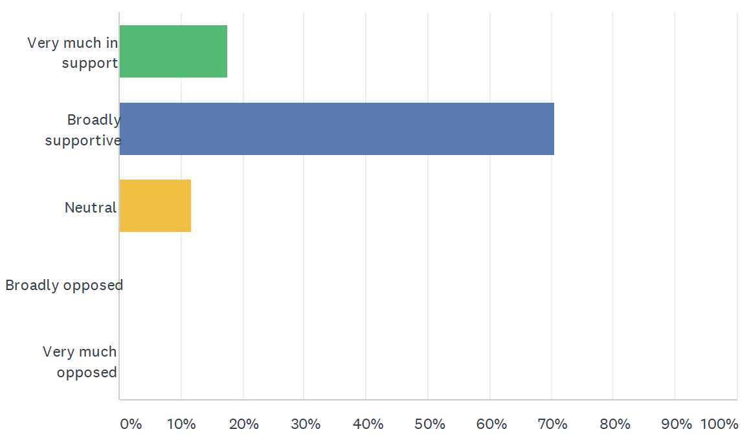

We also identified and prioritised our reasons to support (Q1b) and oppose (Q1c) the data sharing initiative.

Reasons to Support - COVID-19 Data Store and Platform
This initiative improves overall COVID-19 response and management through virus tracking and monitoring as it makes it easier to share data, create dashboards, analyse data, be cost effective, track PPE and available beds, etc., and establish areas/people at high risk. - 16 votes
A reason to be supportive of the initiative is that the data captured could be vital in planning for future healthcare service delivery, patient care, and treatments (such as how we might manage other health areas such as elderly care, cancer etc.). - 13 votes
A reason to support the initiative is that it is a comprehensive dataset that is centralised and not spread across multiple sources/systems, providing efficiency and usability for current and, potentially, for future uses. - 8 votes
A reason to support the initiative is to have a comprehensive dataset to assist future planning and response to pandemic situations. - 6 votes
A reason to support the initiative is that it has been instrumental in helping the NHS to plan their response to covid 19 with regards to patient care, health services, and equipment. - 4 votes

Reasons to Oppose - COVID-19 Data Store and Platform
There has been a lack of transparency and communication with the public about what the Data Store and Platform is, how it is managed, and how it is being used and for what purposes or benefits. - 15 votes
The initiative relies on international corporate entities to operate which could lead to the influence of financial interests and commercial exploitation and present issues related to data ownership and storage. - 12 votes
There are many data inputs, users, and people/organisations accessing the Data Store and Platform which creates additional considerations for data security and management, and ensuring it is being used properly (“checks and balances”). - 7 votes
The high number of users creates issues and the lack of a complete data access register means it is more difficult to fully track and monitor who is accessing the data when, and for what purposes. - 6 votes
The use of the Data Store and Platform for non-COVID related data, analysis, or information is a reason to oppose the initiative. - 3 votes
A reason to oppose the initiative is uncertainty around whether or not patient wishes in regards to decisions to opt-in or opt-out have been respected. - 3 votes

Q2 What should the future of the data sharing initiative be?

We heard arguments from witnesses and then voted on two multiple choice questions about what we believe should be the future of the NHS Covid-19 Data Store and Platform.

Q2a: For how long should the initiative continue?

Answer choices | Responses | Percentage
As short a time as possible | 0 | 0%
Only as long as the Covid pandemic continues and emergency powers are in place | 3 | 18%
As long as it is valuable (potentially beyond the pandemic and for Covid and non-Covid uses) | 14 | 82%
Something else | 0 | 0%
TOTAL | 17 | 100%

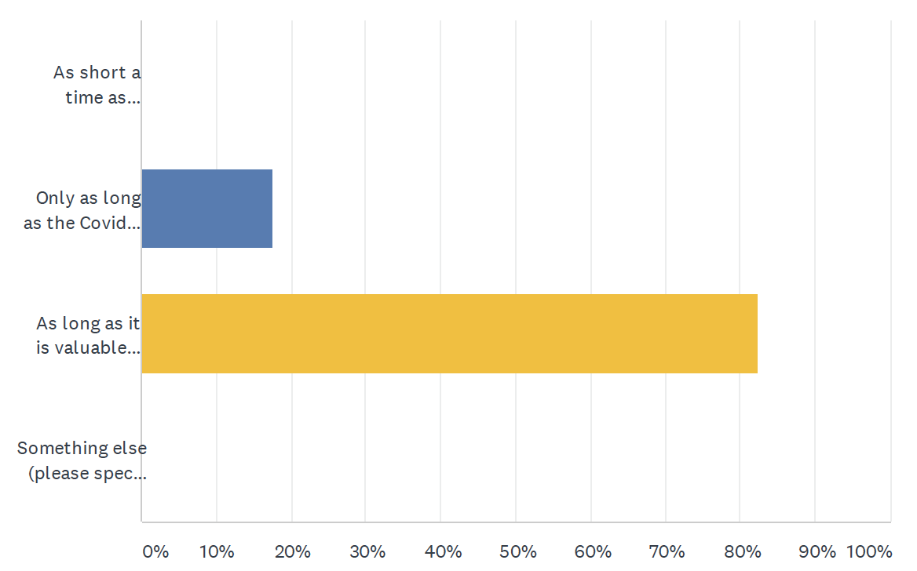
When voting on this question in the online questionnaire, we were each asked to give a brief reason for our answer. Reasons will be analysed and reported in the Juries’ Report in June.

Q2b: By whom should these decisions be made?

Answer choices | Responses | Percentage
An independent advisory group of experts and lay people | 3 | 18%
The minister or organisation accountable for the data initiative | 0 | 0%
Parliament | 11 | 64%
Someone else | 3 | 18%
TOTAL | 17 | 100%

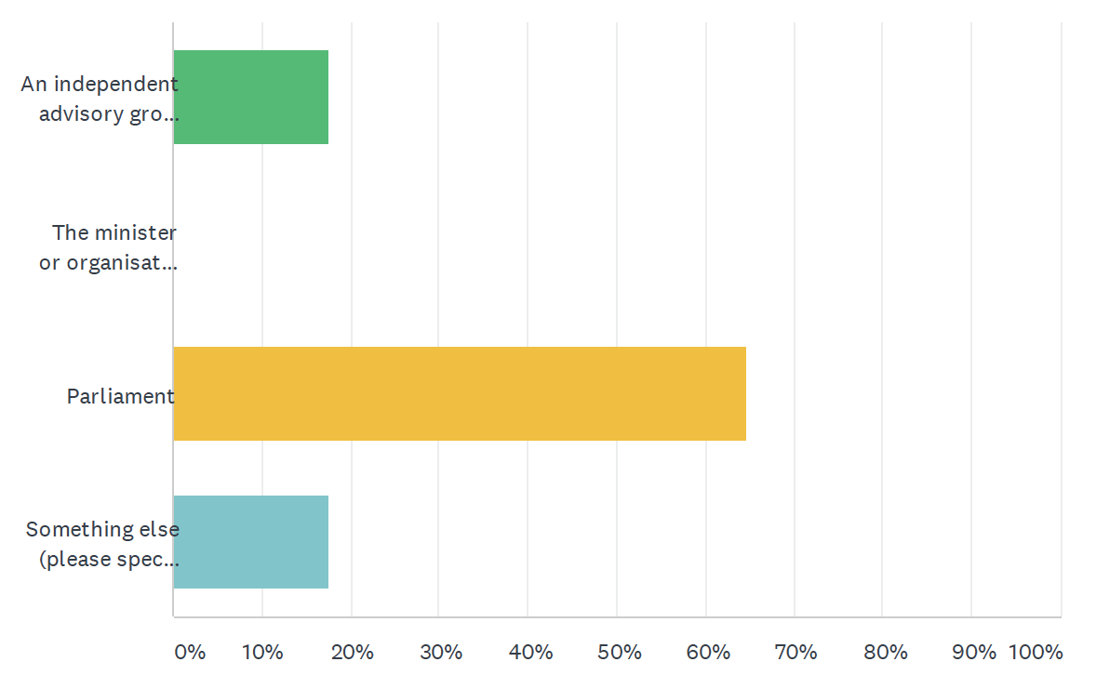

When voting on this question in the online questionnaire, we were each asked to give a brief reason for our answer. Reasons will be analysed and reported in the Juries’ Report in June.

We were also asked two further questions about the future of the data sharing initiative:
- What actions, if any, could be taken to engender greater public trust in the initiative? (Q2c)
- How could or should the initiative and its uses be usefully changed in the future (if at all)? (Q2d)
We worked together in groups to identify and prioritise our answers and reasoning to these questions. Our answers and most important reasons for those answers are set out in the two tables below.

Data Store and Platform - Future Changes
There is a need to increase the transparency of current and proposed uses of this platform (e.g. who is using it and what they are using it for, any uses beyond the pandemic response). This will be especially important if it is decided to maintain it beyond COVID-19 emergency powers.
One useful change to be made to the initiative in the future could be to address some of the connections between the data store and companies that have been previously suggested to be problematic (Faculty Science). This would be a useful change because it would increase public trust.
The Data Store and Platform have been essential instruments in making decisions thanks to the useful information and reports during the pandemic. One useful change in the future could be to give the possibility to update the records/information directly by workers on the frontline so that it might increase accuracy.
The initiative is currently reliant on the temporary COPI notice that was introduced in March 2020 and expires in September 2021. This would need to be reviewed and a new legal framework introduced and agreed upon for ongoing implementation.

Data Store and Platform - Engender Public Trust
It would engender public trust to communicate more effectively regarding who has access to the Data Store and Platform, what they’re doing with the data, and the governance and auditing of the data. It would be valuable to put this information in more accessible places for the public (social media, radio, TV etc) so people could benefit from increased awareness about changes and understand how this affects how their data is used and be aware of their ability to opt-out.
Moving the data initiative to a trusted research environment such as NHS Digital could help to engender public trust.
Creating an app or website structured to be easily understandable to share information about the initiative and how it could improve care could help people/patients better understand the initiative and be part of a pandemic program.
A proper review of the legality of any new framework to be passed in parliament outside of COVID-19 along with a public consultation to properly inform and gauge true public feeling about this would build trust.
We believe that there is a need for greater transparency around the privatised companies that have used data to build platforms and what the need is for the data going abroad. What are these companies doing with this data, are they just a storage facility or are they providing models and analysis using our data? This information is missing and needs to be shown to the public.

Data Sharing Initiative: Early Warning System

The data initiative being considered here is the Early Warning System, a product within the Covid-19 NHS Data Store and Platform "ecosystem". It uses data from the Data Platform to make forecasts about demands on the NHS in England. This is one of two sub-case studies we considered (the other being the Immunisation and Vaccination Management Capability – see section 2.4). For these sub-case studies, we had just two questions to answer: 1a and 2a.

Q1a How supportive are you of the decision to introduce this data sharing initiative in 2020 as part of tackling the COVID-19 outbreak?

Answer choices | Responses | Percentage
Very much in support | 8 | 47%
Broadly supportive | 8 | 47%
Neutral | 1 | 6%
Broadly opposed | 0 | 0%
Very much opposed | 0 | 0%
TOTAL | 17 | 100%

We each answered the above question along with an individual brief reason for our answer using an online questionnaire. Those free-text reasons will be analysed and reported in the Juries’ Report in June.

Q2a: For how long should the initiative continue?

Answer choices | Responses | Percentage
As short a time as possible | 1 | 6%
Only as long as the Covid pandemic continues and emergency powers are in place | 0 | 0%
As long as it is valuable (potentially beyond the pandemic and for Covid and non-Covid uses) | 16 | 94%
Something else | 0 | 0%
TOTAL | 17 | 100%

When voting on this question in the online questionnaire, we were each asked to give a brief reason for our answer. Reasons will be analysed and reported in the Juries’ Report in June.

Data Sharing Initiative: Immunisation and Vaccination Management Capability

The data initiative being considered here is the Immunisation and Vaccination Management Capability, a product within the Covid-19 NHS Data Store and Platform "ecosystem". It uses data from the Data Platform to help manage the implementation of vaccines in England. This is the second of the two sub-case studies we considered (the other being the Early Warning System – see section 2.3). For these sub-case studies, we had just two questions to answer: 1a and 2a.

Q1a How supportive are you of the decision to introduce this data sharing initiative in 2020 as part of tackling the COVID-19 outbreak?

Answer choices | Responses | Percentage
Very much in support | 11 | 65%
Broadly supportive | 5 | 29%
Neutral | 1 | 6%
Broadly opposed | 0 | 0%
Very much opposed | 0 | 0%
TOTAL | 17 | 100%

We each answered the above question along with an individual brief reason for our answer using an online questionnaire. Those free-text reasons will be analysed and reported in the Juries’ Report in June.

Q2a: For how long should the initiative continue?

Answer choices | Responses | Percentage
As short a time as possible | 1 | 6%
Only as long as the Covid pandemic continues and emergency powers are in place | 0 | 0%
As long as it is valuable (potentially beyond the pandemic and for Covid and non-Covid uses) | 16 | 94%
Something else | 0 | 0%
TOTAL | 17 | 100%

When voting on this question in the online questionnaire, we were each asked to give a brief reason for our answer. Reasons will be analysed and reported in the Juries’ Report in June.

Data Sharing Initiative: OpenSAFELY and its access to GP data

The data initiative being considered here is the software OpenSAFELY and specifically the access it currently provides to general practice (GP) data for research purposes. Researchers write and software queries to extract anonymised data directly from the GP patient electronic records. The legal basis for this data sharing initiative, and specifically for the access it is granted to GP electronic records, were the temporary provisions in the COPI Notices issued in 2020 (and subsequently renewed until September 2021).

Question 1 asks how supportive we were of the decision to introduce the data sharing initiative in Spring 2020. We voted on the multiple choice question (Q1a).

Q1 How supportive are you of the decision to introduce this data sharing initiative in 2020 as part of tackling the COVID-19 outbreak?

Answer choices | Responses | Percentage
Very much in support | 11 | 65%
Broadly supportive | 6 | 25%
Neutral | 0 | 0%
Broadly opposed | 0 | 0%
Very much opposed | 0 | 0%
TOTAL | 17 | 100%

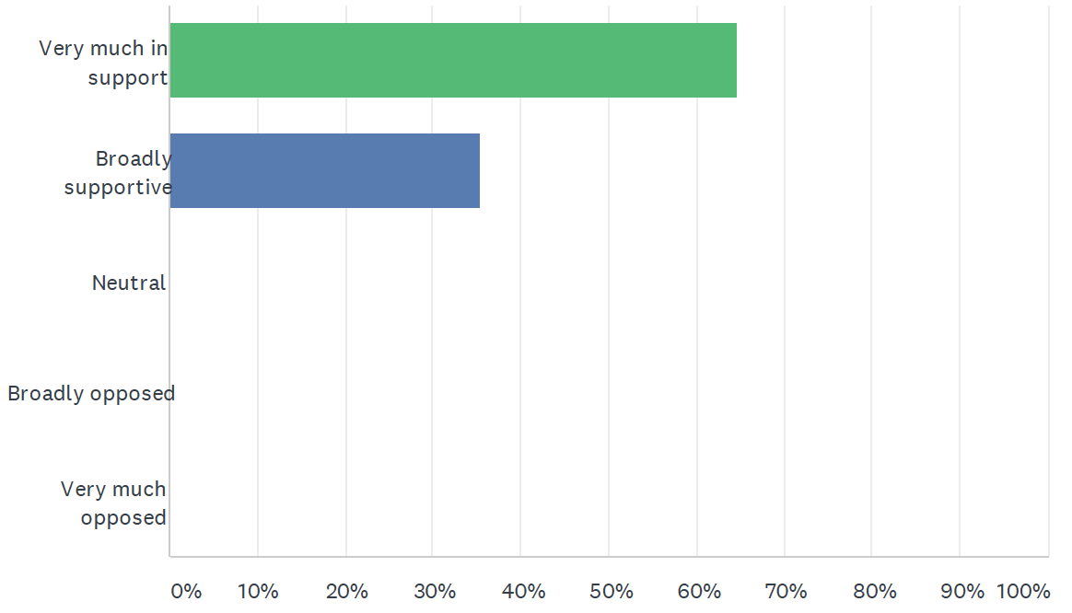

We also identified and prioritised our reasons to support (Q1b) and oppose (Q1c) the data sharing initiative.

Reasons to Support - OpenSAFELY
OpenSAFELY was developed by doctors, funded by Wellcome Trust grants, and is not currently reliant on commercial funding. The initiative is therefore, by its design, more transparent and accountable as opposed to an initiative created by a commercial third party. - 14 votes
The initiative provides quick and regular reports about data that can help decision makers, and has helped to inform NHS policy, such as the vaccination programme priority and shielding list. - 12 votes
The initiative does not transfer or store data, meaning we do not have another platform holding vast quantities of data and the accompanying risk of it being leaked. - 7 votes
Requests for information are scrutinized on application and results are anonymised and are again scrutinised prior to release to the requestor. - 5 votes
OpenSAFELY does a good job of informing decision makers of its research and findings, aiding decision making and increasing levels of public trust. - 4 votes
The initiative has varying levels of access; it restricts the level of data available depending on the need of the user/requests for information. No user has full access to patient summary care records. - 3 votes
Requests for data are audited and logged. - 3 votes
Initiative findings have been disseminated into peer reviewed academic journals, opening up scrutiny and by engagement with the wider public via web and social media. - 1 vote
The initiative has the ability to extract specific information from a vast amount of data, aiding the effectiveness of research. - 1 vote
COPI regulations might be able to be easily addressed. - 0 votes

Reasons to Oppose - OpenSAFELY
Aside from the current COPI regulations, the legal basis and governance is unclear / not fully established. - 8 votes
The data accessed by OpenSAFELY could instead be managed and accessed by NHS Digital. - 8 votes
OpenSAFELY does not provide the opportunity for the public to opt-out; considering the large data pool, the option to opt-out should not significantly affect the statistical analysis of those seeking to do data assessment. Furthermore, it is unclear whether patients will be given the opportunity to opt-out post-Covid. - 6 votes
There is not yet a system in place for full and ongoing transparency in terms of the users and their uses of the platform / initiative (failure to extend its level of output transparency to all stages leading up to and including output). - 5 votes
OpenSAFELY, as a tool, may be used for reasons not initially intended for; data accessed by third parties could be used for other reasons if it is not managed properly or if any further access is allowed post-Covid. - 5 votes
NHS England has requisition that OpenSAFELY do not release some of the data and this does not show true transparency in terms of data use. - 5 votes
It can only provide limited data assessment; it is not a predictive tool and does not have access to the NHS Covid-19 Data Store. - 3 votes

Q2 What should the future of the data sharing initiative be?

We heard arguments from witnesses and then voted on two multiple choice questions about what we believe should be the future of the access provided to GP records by OpenSAFELY.

Q2a: For how long should the initiative continue?

Answer choices | Responses | Percentage
As short a time as possible | 0 | 0%
Only as long as the Covid pandemic continues and emergency powers are in place | 1 | 6%
As long as it is valuable (potentially beyond the pandemic and for Covid and non-Covid uses) | 16 | 16%
Something else | 0 | 0%
TOTAL | 17 | 100%
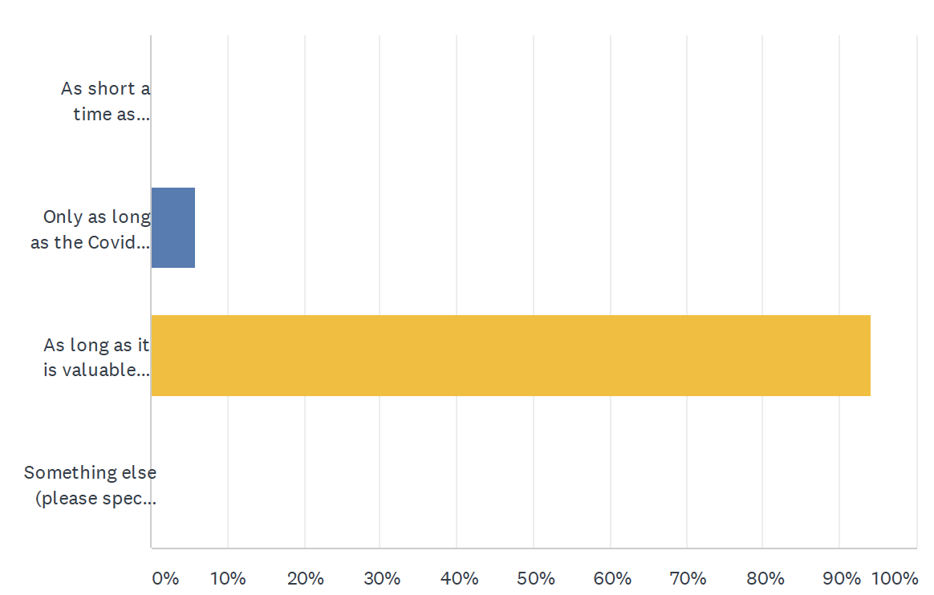

When voting on this question in the online questionnaire, we were each asked to give a brief reason for our answer. Reasons will be analysed and reported in the Juries’ Report in June.

Q2b: By whom should these decisions be made?

Answer choices | Responses | Percentage
An independent advisory group of experts and lay people | 7 | 41%
The minister or organisation accountable for the data initiative | 0 | 0%
Parliament | 7 | 41%
Someone else | 3 | 18%
TOTAL | 17 | 100%

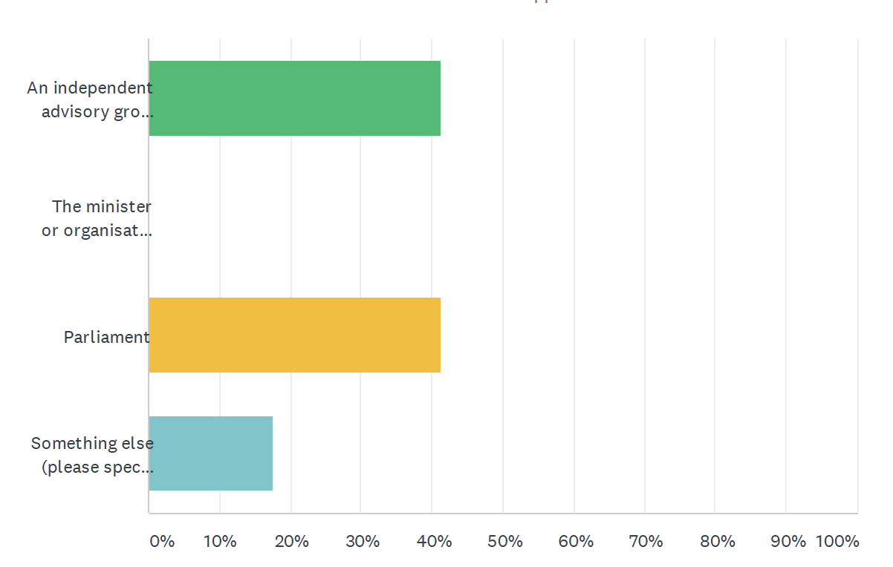

When voting on this question in the online questionnaire, we were each asked to give a brief reason for our answer. Reasons will be analysed and reported in the Juries’ Report in June.

We were also asked two further questions about the future of the data sharing initiative:
- What actions, if any, could be taken to engender greater public trust in the initiative? (Q2c)
- How could or should the initiative and its uses be usefully changed in the future (if at all)? (Q2d)
We worked together in groups to identify and prioritise our answers and reasoning to these questions. Our answers and most important reasons for those answers are set out in the two tables below.

OpenSAFELY - Future Changes
This initiative could be usefully changed in the future by the OpenSafely team working more closely with NHS Digital and sharing expertise. This would hopefully permit the building of a unique and highly effective platform for use in future pandemics or similar health crises.
This initiative could be usefully changed in the future to allow researchers to access GP Patient records outside of the pandemic. This would allow for operational research such as identifying variation in care. The caveat to this change would be that it has been reviewed, scrutinised and approved following the processes that were in place prior to the COPI notice.
This initiative could be usefully changed in the future by reviewing and agreeing to more secure legal requirements for the next 3 years (or beyond) via an updated legal framework.
This initiative could be changed in the future to work alongside / be aligned (integrated) with the Covid 19 Data Store for research into existing and/or possible future health issues. This could also be a tool to assist with the Early Warning System. Alignment or integration might reduce the doubling-up of information and could create a more succinct platform that draws on each system's strengths. However, it needs to be made transparent at the outset with total anonymity of the data used and results published in a way the general public can easily access them.
This initiative could be usefully changed in the future by NHS England and OpenSAFELY publishing all the data that was initially requested to not be published and the requestors requirement for it and not holding anything back or providing valid reasons for withholding results.

Engender Public Trust - Responses
Actions to engender public trust could include having a full review of initiative once the current COPI notice expires and publishing a public report on that review. This would show whether the initiative has only been used the way it was intended (i.e. for COVID-19 pandemic response) during the period covered by the COPI notice.
OpenSafely has already made a good effort in engaging with the public. In the future this could be built on by advertising where further information can be found, particularly in areas that will capture the largest and most diverse demographic i.e. social media, television adverts. Once legal footings have been established there needs to be clear information as to how the public can opt out if they wish to do so.
In order to engender further public trust in this initiative it would be helpful for NHS England and the government, as users of OpenSafely, to publicly acknowledge the work they have done and are doing in relation to COVID-19 research.
The development of a ‘Public facing’ website with functionality restricted to comply with Data Protection, but which allows access to data that would help inform public opinion and demonstrates accountable governance and controls would highlight that OpenSafely is transparent and accountable.
OpenSAFELY have made efforts to engage the public, but have admitted that more needs to be done. Advertising can be done using local councils, local medical centres, local newspapers , local TV stations and explaining the benefits and advantages why OpenSAFELY was required for COVID 19, and why needed going forward.
Even though the data used has been anonymised the public needs to be made aware that their data is being used and also made aware of the opt-out if they so wish to do so. Open Safely also needs to continue to publish their results in an easily accessible and understandable form.
If OpenSAFELY is used post-COVID-19 for other purposes, any requests from third parties should be heavily scrutinised and tracked. This initiative should only be used for public health reasons and not for political or commercial gain.

After considering each data sharing initiative, we were asked to consider a final question:

Q3 What lessons could be learned for the future?

The first part of the question concerned lessons for future pandemics and the second part was around lessons learned which could be useful outside of pandemics. We worked together in groups to identify and prioritise our answers and reasoning to these questions.

Lessons for Future Pandemics - Responses
One of the most important lessons we can learn from these initiatives is that transparency with the public is key and important lesson for future pandemic data initiatives is to engage with the public more about what is being done with their data and why, and to only use data for health care, planning and research reasons related to that pandemic.
An important lesson would be to have more interoperable systems available. Since the data is already on a particular platform and these platforms should all be trusted, sharing across these platforms could improve preparation of reports and monitoring the pandemic and response would be more achievable for decision makers.
More transparency about changes to data and information about how it is being used would be important for future pandemic data initiatives because it allows the public to make informed decisions about whether they feel comfortable with their data being used. This includes letting them know that they have the option to opt-out.
Plan for future dissemination of information in order to avoid the pitfalls experienced in this pandemic and to avoid failing to be seen as open and transparent, specifically (but not exclusively) in respect of drawing on patient data and its uses.
Plan for the future by holding an Inquiry into response to this pandemic and learn from the lessons by preparing for the next pandemic and having systems in place so they don’t have to be created in an emergency.
‘Emergency’ measures (ie COPI) do help introduce useful initiatives, but at the cost of eroding public trust. This should not be a ‘go to option’ in future situations. Lack of public trust can undermine effectiveness of new and unnecessary measures.
A full review of how these initiatives have been carried out is vital to ensure that any initiatives used for future pandemics, are based on a sound legal footing.
For future pandemics it will be useful to ensure, where and when feasible, representation of all key stakeholders, particularly in relation to GDPR, in the consideration and implementation of systems which impact the population as a whole and/or use personal data.
It will be important to have a full review of the current Solution Design regarding the implementation of the COVID-19 Data Store and Platform, the EWS, OpenSAFEY, etc., since these were developed and implemented in weeks, as there could be flaws in the solution and the solutions might not be truly fit for purpose.

Lessons for Future Outside Pandemics - Responses
It has been learned that there is a vast amount of data available and that multiple platforms and systems have been developed to filter and use that data in a variety of different ways. Consideration may be given as to the future centralised storage of the anonymised data and strictly controlled levels of access to this data to determine future planning, procurement, performance and thus enhancing patient care.
The use of the Early warning system would be useful for future data initiatives outside of pandemics because it will provide a three week forecast for the NHS etc to help with supplies of oxygen, bed capacities needed, to avoid a workforce stretch, and could be implemented for helping other diseases, projects, and care.
Due consideration must be given with regard to an individual's right to opt out of data sharing and this option should be communicated to the public effectively.
A clear, auditable trail regarding all uses and requests with reasons of data access along with results should be publicly available for independent scrutiny.
The need for forward planning - when ‘governments’ have the impetus to act they can and do find the money and resources. However, with forward planning the overall cost might be a lot less: e.g. the UK Government was forewarned in 2016 that we were not prepared for a pandemic. Had they commenced planning at the time instead of essentially ignoring the ‘advice’ society might not have paid such an immense economic and social cost. Therefore planning outside of an emergency is essential and drawing on resources created during the pandemic and transparently maintaining or taking forward into the post pandemic world of healthcare and allied ventures is fiscally and socially reasonable / sensible.
It is important to know for future data initiatives that there needs to be a robust, legal and transparent framework in place before being established and that the public are made fully aware of what parts of their data are being used, why, what for and that they have the option to opt out. This needs to be a fully engaging campaign that envelopes all demographics, ethnicities and cultures to ensure nationwide trust.
In order to gain people's trust, it is important that all data initiatives ensure that every use of patients data is consensual, safe and transparent.
All the platforms could be useful for a prompt response to medical issues or research. Consequently, this will improve the quality of life and involve the researchers to prevent future diseases or different treatment without too much effort.

The jury process: what we heard and did

This section provides an overview of what we did over the eight days of the citizens’ jury: from 13.00 to 17.30 each day on 16-19 March, and then from 22-25 March 2021. We heard from a range of expert witnesses. We asked questions and collectively captured important information after each presentation. The briefs given to each presenter and their slides will be published online when the set of three citizens’ juries are complete.

Jury Day 1: Context setting

The event began with introductions by jury members, and to the citizens’ jury process and deliberation. This was led by the process designers and facilitators Kyle Bozentko and Sarah Atwood from the Center for New Democratic Processes (formerly Jefferson Center).

We then heard from Dr Alan Hassey, a former GP and health informatician. He was briefed to address the question: “what are patient and care records and how are they used?”. The table below identifies what we prioritised as the most important information to know from his presentation and our question and answer session with him.

What’s Important - Patient Care Records
It is important to know that only certain healthcare professionals have access to patient records and that these may only be shared partially with different clinicians or practitioners under certain conditions. (10)
The NHS has not invested in or developed a centralised system or database where that stores all patient records in one place. (7)
It is important to know that there are steps taken and safeguards in place to protect patient records and track their use (such as the use of codes, anonymisation, audit trails, and differences in which medical professionals can access records). (5)
It is important to know that only certain healthcare professionals and external organisations have access to patient records. (4)
It is important to know that every patient has the right to access their personal records. (3)
It is useful to know what is recorded in records so that these can be maintained accurately, particularly when they are stored in a “cloud” or shared. (3)
Access to patient medical records is strictly regulated and monitored and accessibility may have changed due to current emergency legislation. (2)

Jury Day 2: Background information

Peter Singleton, a consultant specialising in health information governance, began the day with a presentation addressing the question: “what are the normal rules for using and protecting patient records?”. The table below identifies what we prioritised as the most important information to know from his presentation and our question and answer session with him.

What’s Important - Normal Rules for Patient Records
It is important to know that, under “normal rules,” people have the right to opt out of data sharing initiatives as well as having enhanced records via the national “opt out” (which approximately 2.5% of people have chosen to do). (6)
It is important to know what rights you have and how data is collected, shared, stored, and protected via GDPR and that information about GDPR can be accessed online so that people know what these regulations are. (5)
It is important to know that, under normal rules, consent must be given for data sharing or research and that this can be either implied or explicit consent in various circumstances and that, in some cases, consent may not be sought as it is too cost prohibitive or impractical. (4)
It is important to know that under normal data sharing rules, the security of your data is taken extremely seriously by health professionals and clinicians, that only the minimal level of data is available and that, should a data breach occur, it must be recorded and in some cases reported to the ICO. (3)
It is important to know that there is not a single person who “owns” your patient records so individuals can have a better understanding of who can access that data and how it could potentially be used. (3)
Patient records are anonymised and shared, on a case-by-case basis, for care planning and research purposes and the usefulness of some of this data could be altered if too many people were to opt out of some data sharing initiatives. (2)

Peter Singleton then gave a second presentation addressing the question: “How did the normal rules change for the pandemic?”. The table below identifies what we prioritised as the most important information to know from his presentation and our question and answer session with him.

What’s Important - Rule Changes during COVID-19
It is important to know that emergency changes to data sharing and patient records rules were made in response to COVID-19 which have been communicated via COPI notices. These changes were made in order to enhance response to the pandemic and share data and records more easily and effectively. (8)
It is important to know that the emergency rule changes made during the pandemic and communicated via COPI notices are temporary and will be reviewed, modified, and/or returned to “normal” as the COVID-19 pandemic subsides. (8)
It is important to know that all Summary Care Records (SCR) have been changed to “enhanced” (whereas previously this was “opt-in”) which includes additional information. (5)

The final presentation was from Prof David Harper, Senior Consulting Fellow at Chatham House. He was briefed to present on: “planning for pandemics”. The table below identifies what we prioritised as the most important information to know from his presentation and our question and answer session with him.

What’s Important - Planning for Pandemics
There are predictions that in the future pandemics will become more frequent so it is important that we understand the factors which affect the emergence and duration of pandemics (such as animal to human transmission) and that collectively we learn from practices put into place during COVID-19 to prepare more effectively for future pandemics. (8)
It is useful to know that while there are global frameworks (from organisations such as the WHO) relating to responding to and coming out of a pandemic most decisions are made nationally and locally. (8)
It is important to learn what we can from the COVID-19 pandemic in order to reduce its duration and prepare for future pandemics emerging. (6)
It is important to know that in pandemic planning that there is no ‘one size fits all’ approach to coming out of a pandemic and back to ‘normality’ but guidance and planning frameworks do exist. This is useful to know so that the wider public can appreciate the flexibility required in moving out of a pandemic. (5)
It is important to know how data sharing rules (for things like tracking, surveillance, and pandemic response) change during a pandemic. (3)
It is important to know that it is not possible to predict a time span as to how long a pandemic will last when planning because circumstances and responses by governments and countries may be prioritised differently. (2)
It is important to ensure any pandemic planning is clearly communicated and made available to the public as some of the communication during the pandemic has been really confusing for many. (2)

Jury Day 3: Summary Care Record Additional Information

Day 3 was devoted to this data sharing initiative. The first presentation was delivered jointly by Dr Robert Jeeves, GP Lead for Summary Care Record, NHS Digital (neutral content) and John Farenden, Senior Programme Lead, Shared Records Programme, NHSX (persuasive content). The table below identifies what we prioritised as the most important information to know from their presentation and our question and answer session with them.

What’s Important - Summary Care Record Additional Information
It is important to know that there are different levels of access to the SCR depending among healthcare professionals and that this access is safeguarded, controlled, and audited. (7)
It is important to know that healthcare professionals can use information in a summary care record and enhanced summary care record (with additional information) to improve care. (6)
It is important to know how the additional data or records are added to the enhanced SCR, where this information comes from, how it is managed, and how it can be accessed to ensure people’s records are accurate and managed securely. (5)
It is important that people are provided with clear, sufficient, and appropriate information to make an informed choice about whether to opt out of the enhanced SCR system but relatively few people seem to be aware of this. (4)
It is useful to know that since enhanced SCR has been implemented during the pandemic it is now in use for nearly 55 million people and usage has increased by over 25% among healthcare providers. (3)
Patients have a right to opt out of an enhanced summary care record and it is important to know that if you opted out of having your SCR being made available to view that this did not change when enhanced SCR’s were introduced at the start of the pandemic. (3)
It is important to know that any changes made under emergency legislation will have to go back to parliament for approval to be made permanent, providing an additional layer of accountability. (3)
It is important to know that the enhanced SCR with additional information can now be used “away” from care settings due to changes during the COVID-19 pandemic and that these are set to return to “normal” upon the conclusion of the pandemic. (2)

Phil Booth, medConfidential co-ordinator, was briefed to raise concerns and challenges about the data sharing initiative. The table below identifies what we prioritised as the most important information to know from his presentation and our question and answer session with him.

What’s Important - Summary Care Record Additional Information
It is important to know the wide range of emergency uses of SCR additional information during the pandemic and to understand how this information would be used (such as commercial exploitation), how it would be accessed, how it would be maintained post-pandemic (and that the public be consulted) before any future decisions are made. (5)
Relatively few members of the public seem to have been made aware of the SCR additional information and this can lead to decreased trust in the initiative as well as less opportunity to make an informed choice of opting out of the initiative. (5)
It is important to know that while the information is available, NHS Digital doesn’t report to patients when their SCR has been accessed and from where, and by whom. There may be more apprehension if people don’t know this information is available to them and decrease trust in the system. (5)
It is important to know that patients can opt out of their SCR records being shared or used and for people to make informed decisions about this. (4)
It is important to know there are ways that the NHS can be more transparent (e.g. data usage reports, increasing public awareness) about the use of SCRs, the additional information, and what they consist of in the future, as this builds up trust with patients over the use and storage of their confidential information. (4)
It is important to know that not all of the SCR information that was provided is being used. (3)

Jury Day 4: NHS Covid-19 Data Store and Platform

Day 4 was devoted to this data sharing initiative. The first presentation (both neutral and persuasive content) was delivered by Ming Tang, National Director Data and Analytics at NHS England and NHS Improvement. The table below identifies what we prioritised as the most important information to know from her presentation and our question and answer session with her.

What’s important to know re: NHS Covid-19 Data Store and Platform data sharing initiative
Although various organisations can access the data this is limited to very specific purposes, every request for data is scrutinised by a panel of experts, and every use is recorded (with an audit trail) to prevent misuse. (7)
The Data Store and Platform holds all relevant, de-identified COVID-19 data in one place and that it has been tested by external parties to ensure security. (6)
The Data Store and Platform is being used specifically to help the Government and NHS plan their response to Covid 19 by supporting operational planning, tracking, and reporting (but not to inform clinical decision-making). (5)
Communicating with the public about the Data Store and Platform was not prioritised and one of the only ways the data store was publicised was through a blog, which does not seem like a very effective or transparent way to make people aware of its existence. (3)
There may be gaps in data that are caused by incomplete records or inconsistencies when records are imported into the Data Store but steps are being taken to rectify these gaps. (2)
The Data Store and Platform may be useful for supporting future clinical research and planning. (2)
The Data Store is updated “daily” and it can describe and provide, in real time, all the needed information about the pandemic situation. (2)

Phil Booth, medConfidential co-ordinator, was briefed to raise concerns and challenges about the data sharing initiative. The table below identifies what we prioritised as the most important information to know from his presentation and our question and answer session with him.

What’s important to know re: concerns about the NHS Covid-19 Data Store and Platform data sharing initiative
There seems to be a lack of transparency regarding what is happening with data for the Data Store and Platform (e.g. there is no approvals/release register). Although data use may be genuine for COVID-purposes, this lack of transparency could erode public trust if we don’t know how data is stored, where it is archived, who has control, etc. (7)
Several multinational corporations and for profit firms have been involved with developing and implementing the COVID-19 Data Store and Platform. (6)
It is possible that information collected for the COVID-19 Data Store and Platform may have been or may be used for non-COVID purposes (such as for EU exit process). (5)
Use of the Data Store and Platform is currently set to expire and the Government will determine if it should continue operating as it is, if it should be modified or if it stops depending on the potential future benefits and risks. (3)
It is unclear how or whether or not we are able to opt-in or opt-out for our records to be used for the Data Store and Platform. (1)
The benefits of the Data Store and Platform have not been clearly identified (according to MedConfidential) and it is possible some things could have been accomplished without it. (1)
There are a number of disease registries in existence and a COVID registry could be modeled after these. (1)

Jury Day 5: Early Warning System and Immunisation and Vaccination Management Capability

On Day 5 we considered two sub-case studies: firstly, the Early Warning System and then the Immunisation and Vaccination Management Capability. These two data sharing initiatives are products within the NHS Covid-19 Data Store and Platform “ecosystem”.

The first Early Warning System presentation was delivered jointly by Ed Kendall, Deputy Director for Economics (neutral content) and Dr Harrison Carter, National Medical Director’s Clinical Fellow (persuasive content), both from NHS England and NHS Improvement.

Phil Booth, medConfidential co-ordinator, was briefed to raise concerns and challenges about the Early Warning System data sharing initiative.

The first Immunisation and Vaccination Management Capability presentation was delivered by Ayub Bhayat, Director of Insights and Data Platform Capability from NHS England and NHS Improvement.

Phil Booth, medConfidential co-ordinator, was briefed to raise concerns and challenges about the Immunisation and Vaccination Management Capability data sharing initiative.

Jury Day 6: OpenSAFELY

Day 6 was devoted to this data sharing initiative. The first presentation (both neutral and persuasive content) was delivered by Jess Morley, Policy Lead, University of Oxford’s DataLab. The table below identifies what we prioritised as the most important information to know from her presentation and our question and answer session with her.

What’s important to know re: OpenSAFELY data sharing initiative
OpenSAFELY has a two-step approval process for research access, decisions are made by both the NHS and OpenSAFELY, and that all requests sent to the platform are logged with an audit trail. (9)
OpenSAFELY enables safe access to large volumes of near real time data outside of the pandemic, as well as within, which is useful for medical/operational research on behalf of the NHS, government, as well as self-initiated research. (6)
OpenSAFELY is a software platform that is separate from data (GP records) available elsewhere so use of the platform does not mean that researchers are actually using or accessing the data itself and is not connected to the Data Store and Platform. (5)
OpenSAFELY will be launching a public facing website to communicate about the platform and increase transparency and although some uses of the data are not published in their entirety it is “open source” and publishes its code. (5)
OpenSAFELY has four (4) different, set levels of access for individual researchers and no-one has full access to the raw Summary Care Record data held by GP’s. (2)
OpenSAFELY will engage with the public and consult healthcare professionals to determine future uses and applications. (1)
OpenSAFELY is grant funded and is not charging the NHS for use or access to the platform. (1)
It is important to know that OpenSafely provides a degree of academic integrity, separation and independence from the NHS entities and Government. (1)

Phil Booth, medConfidential co-ordinator, was briefed to raise concerns and challenges about the data sharing initiative. The table below identifies what we prioritised as the most important information to know from his presentation and our question and answer session with him.

What’s important to know re: concerns about the OpenSAFELY data sharing initiative
OpenSAFELY seems like a model for what good (or better) transparency and communications regarding a data initiative can look (including a website, press information, and publication of findings and methodology). (10)
OpenSAFELY is designed to respect opt-out requests from patients which is important as it helps with public trust (and the opt-outs don’t have an affect on the results). (6)
OpenSAFELY currently operates through COPI notices but could be continued after the COVID-19 pandemic if a new legal basis is determined. (4)
OpenSAFELY provides research on behalf of the NHS and in response to emerging needs identified by the OpenSAFELY team. (3)
OpenSAFELY could potentially be embedded within or housed by NHS Digital if the system were adapted to be operated by NHS staff. (3)
The OpenSAFELY software doesn’t allow users to directly access GP records or patient data along with various levels of access to the information in the platform. (1)
The Chief Medical Officer currently decides on the projects researched by OpenSAFELY, but in the future third parties could potentially make requests. (1)
OpenSAFELY has an external advisory group (medConfidential has been invited) which increases public scrutiny of the platform. (1)
OpenSAFELY is funded by grants and not through NHS funding. (1)

Jury Day 7: Jury Deliberations

On day 7, we worked together to further develop our thinking about the data sharing initiatives, and lessons learned for the future.

Jury Day 8: Deliberation and report writing (this report)

On the final jury day, we had further deliberations, voted on jury questions, and worked on and agreed the contents of this report.

Appendix A: The jury questions

The three citizens’ juries all consider the same set of questions.

The juries will consider three pandemic data initiatives which were introduced or substantially changed in response to Covid-19::
- Summary Care Record (which was extended to include more data about patients during the pandemic)
- NHS Covid-19 Data Store (which was created in response to the pandemic)
- OpenSAFELY (which uses primary care data for research).

For each initiative, the jury will address the following questions:

- a) How supportive are you of the decision to introduce this data sharing initiative in 2020 as part of tackling the COVID-19 outbreak?
Very much in support/ Broadly supportive/ Neutral/ Broadly opposed/ Very much opposed

- “What are the most important reasons to be supportive?”
- “What are the most important reasons to oppose the initiative?”

- What should the future of the data sharing initiative be?
  - For how long should the initiative continue
    - As short a time as possible
    - Only as long as the Covid pandemic continues and emergency powers are in place
    - As long as it is valuable (potentially beyond the pandemic and for Covid and non-Covid uses)
    - Something else

  - By whom should these decisions be made?
    - An independent advisory group of experts and lay people
    - The minister or organisation accountable for the data initiative
    - Parliament
    - Someone else

  - How could or should the initiative and its uses be usefully changed in the future (if at all)?
  - What actions, if any, could be taken to engender greater public trust in the initiative?
  - What are the main reasons for these answers?

At the end of each jury, the jury will be asked:
- What lessons can we learn from how these pandemic data initiatives were introduced
  - which could be useful for future pandemics?
  - which could be useful outside of pandemics?

There are also two “sub-case studies” for the jury to consider. These are systems reliant on the NHS Covid-19 Data Store:
- The Early Warning System
- The Immunisation and Vaccination Management (I&V) Capability.

The juries will answer two of the above questions about each of these sub-case studies: 1 a) and 2a).

Emergency powers are in place to deal with the pandemic, see: https://www.instituteforgovernment.org.uk/explainers/emergency-powers

