Data Sharing in a Pandemic Citizens’ Juries
Jury 3 of 3 (W & E Sussex) - April & May 2021
Jurors’ Report

A report produced with the 18 members of the jury of adults from West & East Sussex assessing the future of data sharing initiatives introduced in response to the Covid-19 pandemic
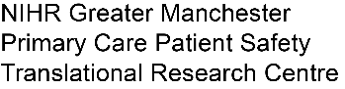
May 6, 2021

Commissioned by:

Designed and delivered by:

Table of Contents
1. Preface 3
About this report 3
1. Statements to Commissioning Bodies, Policymakers and Public 4
2. The jury questions and the jury’s answers 8
2.1 Data Sharing Initiative: Summary Care Record Additional Information 8
Q1 How supportive are you of the decision to introduce this data sharing initiative in 2020 as part of tackling the COVID-19 outbreak? 9
Q2 What should the future of the data sharing initiative be? 11
2.2 Data Sharing Initiative: NHS Covid-19 Data Store and Platform 15
Q1 How supportive are you of the decision to introduce this data sharing initiative in 2020 as part of tackling the COVID-19 outbreak? 15
Q2 What should the future of the data sharing initiative be? 16
2.3 Data Sharing Initiative: Early Warning System 19
Q1a How supportive are you of the decision to introduce this data sharing initiative in 2020 as part of tackling the COVID-19 outbreak? 19
Q2a: For how long should the initiative continue? 20
2.4 Data Sharing Initiative: Immunisation and Vaccination Management Capability 20
Q1a How supportive are you of the decision to introduce this data sharing initiative in 2020 as part of tackling the COVID-19 outbreak? 20
Q2a: For how long should the initiative continue? 21
2.5 Data Sharing Initiative: OpenSAFELY and its access to GP data 22
Q1 How supportive are you of the decision to introduce this data sharing initiative in 2020 as part of tackling the COVID-19 outbreak? 22
Q2 What should the future of the data sharing initiative be? 24
Q3 What lessons could be learned for the future? 27
3. The jury process: what we heard and did 29
Jury Day 1: Context setting 29
Jury Day 2: Background information 29
Jury Day 3: Summary Care Record Additional Information 29
Jury Day 4: NHS Covid-19 Data Store and Platform 29
Jury Day 5: Early Warning System and Immunisation and Vaccination Management Capability 29
Jury Day 6: OpenSAFELY 30
Jury Day 7: Jury Deliberations 30
Jury Day 8: Deliberation and report writing (this report) 30
Appendix A: The jury questions 31

Preface

About this report

This is a report from the 18 members of the citizens’ jury who met online over eight afternoons between 27 April and 6 May 2021 to hear evidence from a wide variety of witnesses, to deliberate together, and to make recommendations. 18 jury members drawn from a cross-section of adults across England were recruited; unfortunately one person had to withdraw from the jury after day three for personal reasons. It is the first of a set of three citizens’ juries on data sharing in a pandemic commissioned by the University of Manchester (with funding from the National Institute for Health Research Applied Research Collaborative), NHSX (part of NHS England and NHS Improvement), and the NHS National Data Guardian’s Office. The first jury was held in March (consisting of jurors from all of England), the second in April (with jurors from Greater Manchester) and the third jury was in April and May with jurors drawn from across West and East Sussex.
This report was constructed using the words of the 18 jury members, using statements they prepared together. A draft version was reviewed and agreed by jury members as part of the jury process on 6 May before being reformatted, and distributed to members of the jury.
A Juries’ Report about all three juries with additional information (e.g. on jury recruitment) will be produced by Citizens Juries c.i.c. and published online in June 2021. Other materials including presenters’ slides will also be published online.

Statements to Commissioning Bodies, Policymakers and Public

At the conclusion of the jury, participants chose to share the following about their experience and collective work assessing the pandemic data sharing initiatives and their future:

Statement to Neighbours

I don't think it is important for them to know - only my wife knows I’m doing it and she does not seem to be interested.
That there are different strands of opinion based on life experiences, values etc. But the overwhelming consensus is that the public should have been consulted in all aspects of each of these initiatives. You learn things that are not made readily available to the public and this is a problem because this is about the public and advised that is for the public.
In this jury, we were learning about the data sharing initiatives through presentations made and used in the covid pandemic, analysing if they were beneficial or risky and what their future should entail
The people involved (members of the jury and facilitators) are invested in ensuring that all opinions (differing and opposing) are voiced, given adequate consideration and most importantly respected regardless of their own personal viewpoint.
It was informative with valuable information provide in the presentation. The experience was engaging, interactive and interesting.
The most important thing for friends/family or neighbours to know is that all conclusions that have been made during this time have come after the unbiased consideration of numerous perspectives.
Together we were shown informative presentations from a neutral, persuasive and opposing view. In small groups we came up with relative questions to challenge, gain further understanding and get clarification from the speakers. We then went on to deliberate what we had heard and recorded our findings, both as a group and as individuals
It has been a fascinating experience, a blend of finding out a huge amount of new knowledge around the modern issue of data, an enjoyable sociable experience of meeting lots of new people, and good for the brain to try and puzzle out some ethical and moral issues.
I joined the jury with no pre conceived ideas about data and sharing through the pandemic, In the real world I am very relaxed about my Data so to listen to the presentations and thoughts of my fellow jurors was very interesting and I will take away different ideas. I found the way it was run excellent and helped promote good discussions between us all. I would recommend anyone to participate in any future jury's.
An interesting eight days, being informed about the covid 19 Data initiatives and its future. Giving our own opinions as well as discussing with 17 other jury members (chosen from over 700 applicants) which also led to giving group opinions and sometimes changing my own opinions in the process
Being on the Jury was far more in depth than I first realised, It has made me think long and hard about all the different issues and initiatives required to deal with a worldwide pandemic. Before I did not fully appreciate the sheer scale of it.
On a personal note it has been enjoyable meeting others and hearing other people’s views.
I feel proud of what we all achieved and hope it assists the NHS in the future.
It is important for them to know that it gives a chance for the public to voice their opinions on matters that generally would be decided by experts, policy makers, therefore the Citizen's Jury is extremely important so to voice either views or concerns that the greater public may have. I was unsure if I would find it interesting, but the way it is run is so well executed that it makes learning about a policy very easy and interesting.
We learned about the data initiatives that were introduced in England because of the Covid pandemic. I did not know what a data initiative was, and do now! It was very interesting and multi layered and we were facilitated in answering lots of questions and to give our opinions in interesting ways. There was 18 of us from around Sussex. Every day at least a few made me laugh. The humour was good. I loved hearing what other people's views were. It's been a very enjoyable experience. Kyle and Sarah, the facilitators were great at drawing out people and prompting answers and discussions. Loved their accents.
My experience over the past 2 weeks has been very informative both on the subject and the process, trying to explain the process and reason for the Jury to family was interesting.
As they had not come across this before, I explained it was on behalf of Manchester Uni that they were trying to garner the public's view on a number of initiatives the government brought in under the covid 19 emergency powers. They had no idea about the COPI notices and their right to opt out of SCR data sharing.
This has been an extremely enjoyable experience and I have learnt a lot.
Firstly, this has been a great collaboration between a group of people I have never met before. In addition it has been an education on many issues I was not aware of. I believe
the Citizen's Jury to be a very worthwhile, mind expanding and enjoyable experience.
I sincerely hope Citizen's Jury's will become an initiative that will be applied many times
in the future... In conclusion, I would gladly participate again !
We looked at data in the NHS. We went through the available data, starting with what we all know as GP records (SCR). The Covid emergency enabled the use of data without telling us.
This was an additional part to the GP records. We then looked at the datastore and data platform., run by palantir and microsoft. This was a package that handled a lot of data quickly and was part of the figures we got each day This worked well as an off the shelf package, but has commercial interests in its suppliers. it also moved data around onto other systems
The third one we looked at was Opensafely, run by a research group in Oxford. This skimmed data that was in GP records only getting the results without moving data and personal details.
We all agreed that the data did help us manage the pandemic, but going forward, the one with the most safety, transparency and lowest impact on security was Opensafely
It has been a very interesting and informative experience being in this jury, learning about the different initiatives that have been taken to respond to the Covid-19 pandemic. But also how these initiatives, although very beneficial in different ways, they have been taken lacking in transparency and without informing properly the public about how their data has been used.
My compliments to the facilitators... Great job !
I have spent the last 8 days with an interesting group of people discussing the ways in which the NHS has obtained vital data to deal with the Covid pandemic, and how the intiatiives could be carried forward for future pandemics/medical emergencies and, indeed, for future issues regarding the nation's health and wellbeing

Statement to Commissioners and the Public

That the public do care and are engaged with this process when they're actually made aware of it. To understand that it should be a duty of consideration to inform the public about data processing/farming/gathering whether or not it is deemed convenient or not.
It is important that people should know that the presentations were extremely informative and the Q&A sessions felt truthful/honest and helped us make our decisions both for and against the initiatives.
I would say that everybody in the jury was given an equal opportunity to have their voice and perspective heard
I think any one outside this jury session should know that over 8 days there was a lot of debate about all the initiatives and quite in depth discussions we all listened to both sides of the arguments and made genuine decisions via votes
It is important for those involved in the Pandemic Data Sharing Initiatives to realise that transparency is very important to the jury and it is up to the public to make sure that this is achieved
It is important for the public and those involved in the data sharing initiatives to know that these initiatives created during the pandemic may be beneficial, but also can pose potential risks to the privacy of the public
It is important for those involved in the Pandemic Data Sharing Initiative and the public to know that at the core of this exercise is the discussion related to the use and security of their personal information - information that if used appropriately could enhance the quality of life for all in this country. Although, it should be stressed to them that it also poses potential security threats and breaches to their personal information, which they should take seriously as data theft is lucrative business for some. Therefore, it is advisable that the public takes a proactive interest in how their data is accessed and used.
I think it is important for those who have been involved in the Data Initiatives to know that an over riding feeling in the jury is that more transparency, and much sooner, would have gone a long way to engender public trust. I think its important that the public know what we as a jury were given clear information on the benefits of each initiative but also a counterpoint as to the problems around these emergency initiatives.
It's critically important for the people involved in the pandemic data sharing initiatives to take full consideration and assessment of each view points and suggestions provided by the jury's member. Its also important to analyse the concern raised during the past two weeks especially topic revolving around transparency and communication provided to the general public domain and making sure all policies and regulations are followed to unable safeguarding and protecting sensitive patients medical record.
I think it is important to know that these initiatives were set up hastily to help with the Covid 19 pandemic. As a jury we have looked and discussed best ways to move forward with this and see what is still required and how to improve on what has been started with the aim to improve healthcare and gain public trust and knowledge about their data in the UK in future
We were a virtual jury over 8 days of 18 ,comprised of a cross section of people from West sussex. It was good fun and informative.
We were privileged enough to get many presentations from experts in data handling and NHS staff involved. The set up was arranged so there was time to discuss all aspects of the presentation and question the presenters.
They were all open and honest and we learnt a huge amount about data handling and all its issues. Views of all 18 jurors were listened to and part of our final decisions.
The moderators kept the pace moving well and were supportive and friendly. If you are given the chance of taking part- please do it.
Over the past two weeks we have worked together to record our findings on the positive and negatives of the Data Sharing Initiatives. As a group of individuals of all ages and backgrounds, we have been well informed, had very open discussions/debates and all our voices have been heard. Whilst I personally understand the rational behind the Initiatives, a common theme within the Jury was lack of transparency and information. A competent strategic plan equates to an efficient operational process, however the public needs to be educated how this is executed.
The Citizen's Jury has been a unique opportunity. I feel quite privileged to have had the opportunity hear the sincerity, (and in a few cases "the passion") with which the presenters
introduced us to the three initiatives, none of which I had previously been aware of. Which brings me to possibly the single most important issue that I think we all agreed upon and was constantly referred to during the entire 8 days... Namely, the need for more transparency.
As a jury over the past two weeks, we looked in-depth all the Data Sharing Initiatives that has been taken to respond to the Covid-19 pandemic, and it would be important for those involved in the initiatives and the public to know that it really good to see the health care system and research improving and growing, especially to be able to respond in a more proficient way to future viruses and pandemics, but the public has been not informed in a proper way about no one of them and this will be very important for the future to be done and to have the public trust on how their data has been used.
Having discussed the data sharing Initiatives over the past 2 weeks I have learnt that the emergency powers brought in by the government under covid 19, the data sharing was not made public in a transparent way and in a way the public could understand. these powers enabled NHS England to garner information directly from GP records both past and present information and store this information in a data store within a Microsoft and Amazon cloud.
Although this was brought in as an emergency initiative and covered under COPI the Public should have been informed at the time and given guidance to opt out if they felt strongly with regards to their Data being shared.
The consensus of the jurors were that they were not opposed to the changes in data sharing during the pandemic in the 3 initiatives (Summary Care Record with Additional Information, the Data Store & Platform and OpenSAFELY), the general view that the changes in data sharing were necessary and imperative with dealing with Covd-19. Speculating over the material from the presentations has demonstrated that the NHS is currently very disjointed and perhaps not as efficient as it could be, there is a greater need for a more 'centralised' system, but that data is kept safe and secure. The consensus with the jurors regarding the changes in data sharing during the pandemic was that it was not at all transparent to the public that data sharing had changed, what data was now being shared, how it is being used, who has viewed it and how to opt out, moving forward it is extremely important that this is communicated effectively to the public.
We heard from experts on each of the data sharing initiatives that were brought in at the start of the Covid pandemic. Generally we were to give our views on whether these initiatives, individually, shoudl carry on after the COPI notices. We discussed in groups and listened to other people's views and gave our answers as groups and as individuals. A Citizens' Jury is a great way of getting informed public opinion and views without them being maninpulated by media and organisations such as Cambridge Analytica.
I belive the group think generally that a good job has been done, especially considering the time pressures, however concerns about transparency and dubious commercial involvement have been raised. I believe issues should be answered in any future development of the initiative, once the pandemic is over.

The jury questions and the jury’s answers

The questions for the citizens’ jury, and our answers/recommendations are set out below. The jury questions are in italics. Our answers explain, in our own words, what we thought about the pandemic data initiatives we considered. We voted to prioritise what we considered to be most important of our ideas, and the numbers of votes are shown throughout section 2 (often votes exceed 18 in total because we were given more than one vote each).
This section begins with jury questions (see Appendix A) and answers about the jury’s three pandemic data sharing initiative case studies, and two sub-case studies (both of which are products within the NHS Covid-19 Data Store and Platform):
- Summary Care Record additional information
- NHS Covid-19 Data Store and Platform
  - Early Warning System sub-case study
  - The Immunisation and Vaccination Management Capability sub-case study
- OpenSAFELY and its access to GP data
We had fewer questions to answer about the two sub-case studies and consequently less time to consider them (half a day each).
At the end of this section of the report are our answers to further questions about lessons learned for future pandemics.
The process we went through to reach our conclusions is described in section 3.

Data Sharing Initiative: Summary Care Record Additional Information

The data initiative being considered here is the extraction of “additional information” from over 50 million computerised patient records held in general practices’ (GPs’) computer records into the Summary Care Records for those patients held on the national “Spine”. The Summary Care Record is used to view information (including the additional information) about a patient by those providing care. Prior to the pandemic this additional information was only uploaded into a patient’s Summary Care Record with the patient’s express consent. In Spring 2020 the data from GP records was added without asking patients in order to assist with patient care during the pandemic. The initiative was a direct response to a direction within the COPI Notices issued in 2020 (subsequently renewed until September 2021).

Question 1 asks how supportive we are of the decision to introduce the data sharing initiative in Spring 2020. We voted on the multiple choice question (Q1a).

Q1 How supportive are you of the decision to introduce this data sharing initiative in 2020 as part of tackling the COVID-19 outbreak?

Answer choices | Responses | Percentage
Very much in support | 11 | 61%
Broadly supportive | 6 | 33%
Neutral | 0 | 0%
Broadly opposed | 1 | 6%
Very much opposed | 0 | 0%
TOTAL | 18 | 100%

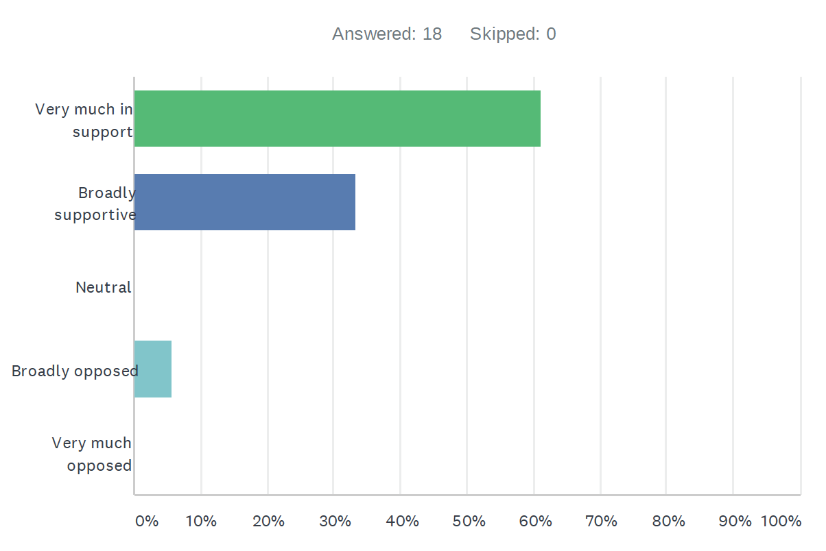

We also identified and prioritised our reasons to support (Q1b) and oppose (Q1c) the data sharing initiative.

Reasons to Support - Summary Care Record Additional Information
The enhanced summary care record and additional information can provide essential information to healthcare professionals in emergency situations or when individuals are unable to communicate. - 12 votes
The Summary Care Record Additional Information made patient records easily accessible to providers which improves patient care and can save lives. - 11 votes
The Summary Care Record Additional Information has helped to improve the response to the COVID-19 pandemic. - 10 votes
The SCR additional information could play a role in future policy planning for the benefit of public health and help prepare to respond to future pandemics or other emergencies. - 10 votes
Patients are still able to opt out of summary care record additional information and previous opt out requests were respected. - 7 votes
The Additional Information can increase efficiency which can save time and money. - 3 votes

Reasons to Oppose - Summary Care Record Additional Information
There has been a lack of transparency about what the initiative or how it was implemented which leads to very little public awareness about how records are being used, by whom, and for what purposes. - 17 votes
The SCR Additional Information presents unique security risks for unauthorised access and numerous entry points for accessing the records. - 13 votes
The potential risk of misuse, commercial exploitation, or nefarious uses of this information is a reason to oppose the initiative. - 13 votes
The implementation of the SCR Additional Information affected nearly 55 million records without seeking consent from individuals. - 7 votes
This initiative was put in place by a COPI and it should be limited to the time covered by the COPI and not renewed especially when there is no current pandemic in England. - 3 votes
This initiative will require additional time and resources to manage and process the data and records. - 0 votes

Q2 What should the future of the data sharing initiative be?

We heard arguments from witnesses and then voted on two multiple choice questions about what we believe should be the future of the Summary Care Record Additional Information data sharing initiative. The witness speaking in support of the initiative argued that the initiative should continue for as long as it is valuable, and that the decision should be made by the organisation accountable for the initiative (informed by patients and other stakeholders). We heard from the challenge witness (Phil Booth from medConfidential) that the initiative should only continue as long as the pandemic continues, and that the decision should be made by an independent advisory group of experts and lay people.

Q2a: For how long should the initiative continue?

Answer choices | Responses | Percentage
As short a time as possible | 1 | 6%
Only as long as the Covid pandemic continues and emergency powers are in place | 1 | 6%
As long as it is valuable (potentially beyond the pandemic and for Covid and non-Covid uses) | 12 | 66%
Something else | 4 | 22%
TOTAL | 18 | 100%

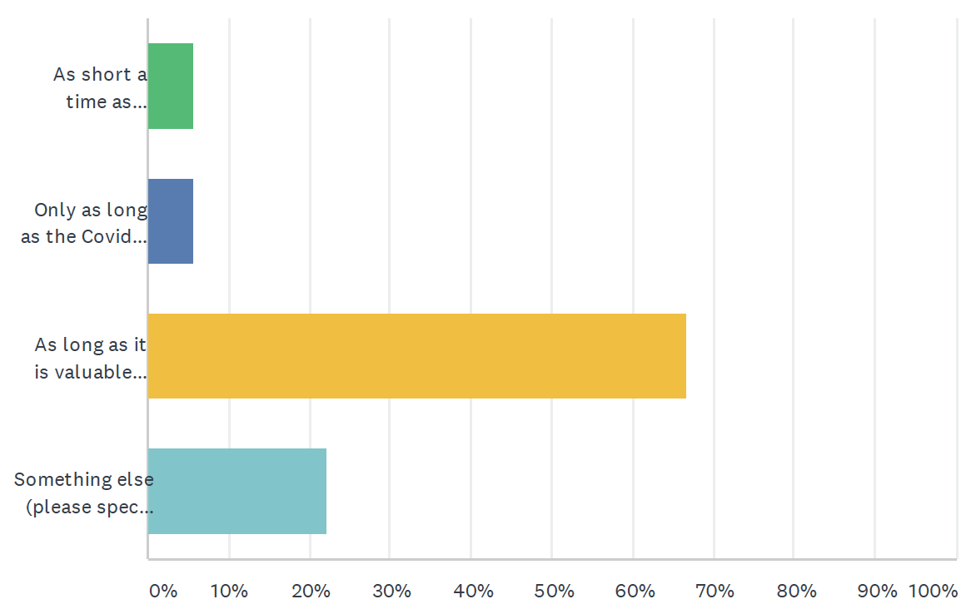

When voting on this question in the online questionnaire, we were each asked to give a brief reason for our answer. Reasons will be analysed and reported in the Juries’ Report in June.

Q2b: By whom should these decisions be made?

Answer choices | Responses | Percentage
An independent advisory group of experts and lay people | 8 | 44%
The minister or organisation accountable for the data initiative | 1 | 6%
Parliament | 1 | 6%
Someone else | 8 | 44%
TOTAL | 18 | 100%

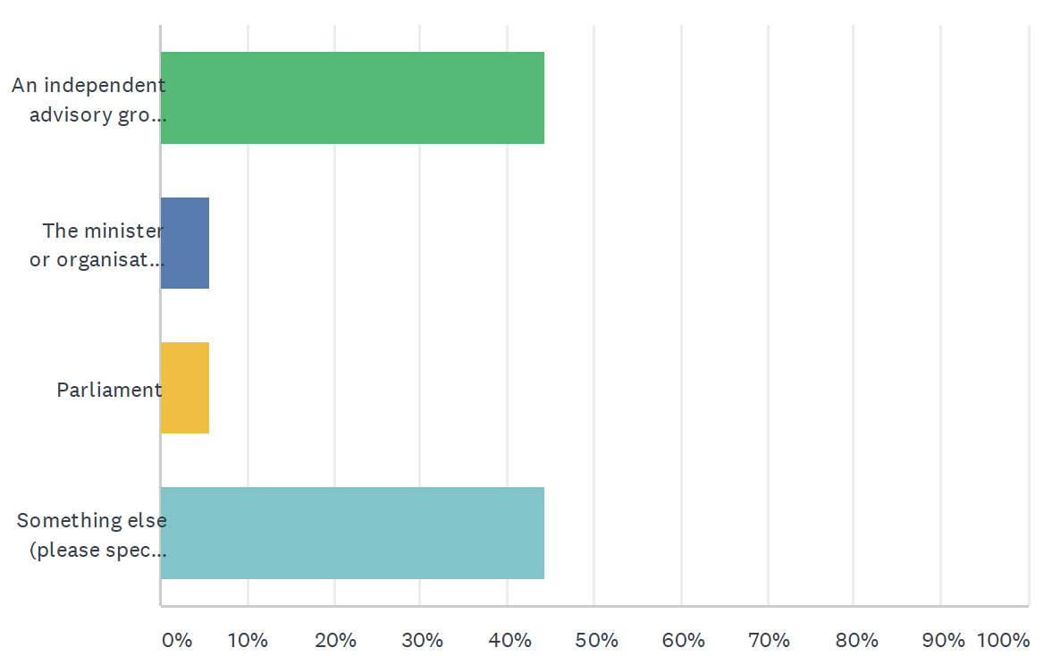

When voting on this question in the online questionnaire, we were each asked to give a brief reason for our answer. Reasons will be analysed and reported in the Juries’ Report in June.

We were also asked two further questions about the future of the data sharing initiative:
- What actions, if any, could be taken to engender greater public trust in the initiative? (Q2c)
- How could or should the initiative and its uses be usefully changed in the future (if at all)? (Q2d)
We worked together in groups to identify and prioritise our answers and reasoning to these questions. Our answers and most important reasons for those answers are set out in the two tables below.

Summary Care Record Additional Information - Engender Public Trust
Details about exactly what and why each section of data is being captured should be made public. This could be done by increased coverage in mainstream media or other communications methods such as a national PR campaign since communication of the vaccine programme, by a simple text, has proven successful.
The NHS should launch public Data Usage Reports to relay how data has been shared and with whom, as well as provide an audit trail via a government gateway or portal on an NHS website so that patients patients can easily and rapidly access information on who has been viewing their SCR to help ensure that unauthorized/unethical access is traceable.
Contact every patient and ask if they are happy to have the Additional Information added to their SCR, as well as explain what this entails (including the consequences) and do not incorporate a patient’s Additional Info into their SCR until a response is received.
Adopt additional layers of security and levels of access within the NHS and among health professionals to build public trust by reducing the possibility of unauthorised access or external breaches.

Summary Care Record Additional Information - Future Changes
The usage of the Additional Info data should be mandated by law for immediate patient care only, not to pass on information about usage stats for medication, areas that have particular needs, etc. as this could be misused in the future.
The enhanced SCR could be more widely publicised through a coordinated PR campaign to engender public trust, especially if it is needed again in a public health emergency.
The change to add the Additional Information to a patient’s SCR should be conveyed to the public clearly so that anyone has the option to opt-out of having the Additional Info captured. This way of informing the public needs to be to the level of individual letters and responses noted on their file.
The initiative could be changed in the future to make it more transparent as to what data and why the data is being captured, which is important in order to build trust in the initiative amongst the general public
Put a system in place that allows patients to see by whom and when their record has been accessed in order to provide greater transparency and build trust in the system as a whole.
Future use of the SCR Additional Information, post-COVID, would require a new legal footing rather than continuing under COPI notices.
GP offices should be responsible for communicating about the inclusion of SCR Additional Info with information about the option to opt-out about included.

Data Sharing Initiative: NHS Covid-19 Data Store and Platform

The data initiative being considered here is The Covid-19 NHS Data Store and Platform "ecosystem", including all the data flowing in and being processed by the Data Platform and associated products, and all the data flowing out. Patient-level and aggregated data flows into the Data Store and is de-identified and held within the Data Platform for use by many different products being used to tackle the pandemic. The products include the Early Warning System and Immunisation and Vaccination Management Capability sub-case studies (see sections 2.3 and 2.4 below). The whole “ecosystem” was created in 2020 in response to the pandemic. The legal basis for this data sharing initiative were the temporary provisions in the COPI Notices issued in 2020 (and subsequently renewed until September 2021).

Question 1 asks how supportive we were of the decision to introduce the data sharing initiative in Spring 2020. We voted on the multiple choice question (Q1a). We also identified and prioritised our reasons to support (Q1b) and oppose (Q1c) the data sharing initiative.

Q1 How supportive are you of the decision to introduce this data sharing initiative in 2020 as part of tackling the COVID-19 outbreak?

Answer choices | Responses | Percentage
Very much in support | 7 | 39%
Broadly supportive | 8 | 44.5%
Neutral | 1 | 5.5%
Broadly opposed | 1 | 5.5%
Very much opposed | 1 | 5.5%
TOTAL | 18 | 100%

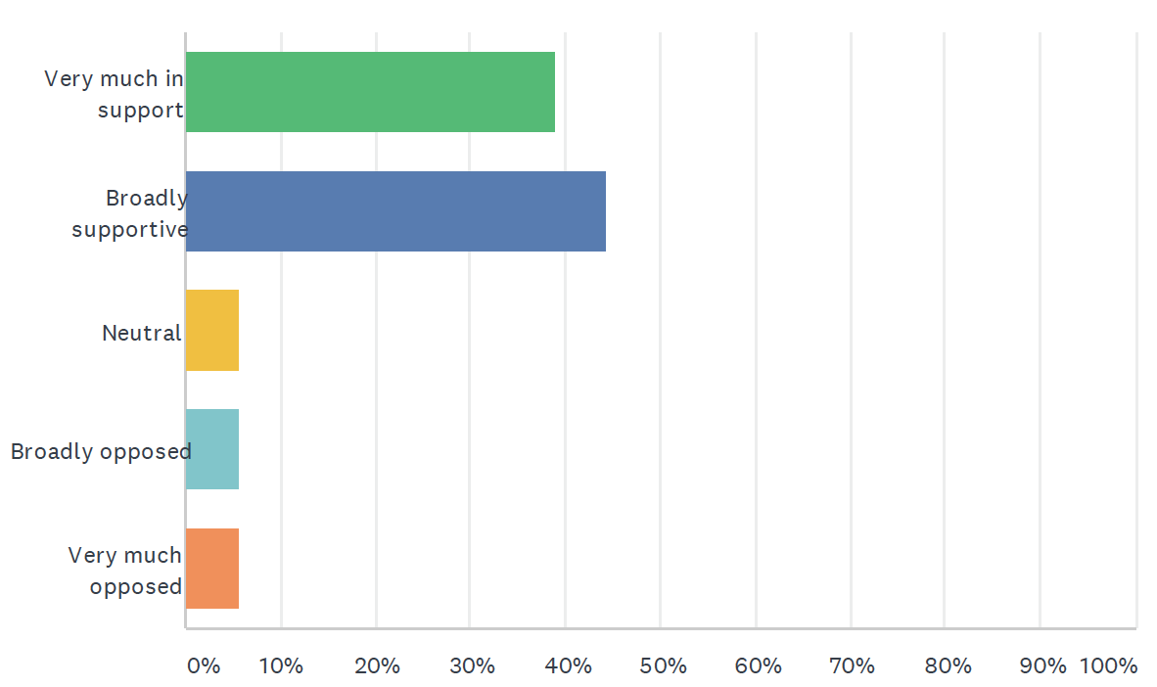

We also identified and prioritised our reasons to support (Q1b) and oppose (Q1c) the data sharing initiative.

Reasons to Support - Data Store and Platform
The Data Store and Platform provides valuable information for researchers working on other Covid-19 research, other diseases, treatments, studying vulnerable groups, etc. - 16 votes
The Covid-19 Data Store & Data Platform have been pivotal in coordinating and synchronising the management of the services and resources required to minimise the detrimental effects Covid-19 has on public health in a timely and standardised manner. - 14 votes
The central database provides speed of response (real-time) nationally. - 7 votes
It is a framework already in place in case of another pandemic or public emergency. - 6 votes
The Data Store and Platform has cost benefits - helping to move equipment and patients around as needed. - 3 votes
Patients have given full consent and maximum notification. - 1 vote
It is helping with the backlog on non-COVID-related waiting lists. - 0 votes

Reasons to Oppose - Data Store and Platform
The involvement of companies with dubious reputations and potentially problematic political affiliations as well as little transparency about outside companies’ involvement in the initiative (eg unpublished contracts, etc.,). - 18 votes
The lack of communication about its introduction and development at the beginning of the pandemic has led to very low public awareness about how the initiative is used, what data is shared, by whom, and for what purposes. - 16 votes
The misuse of COPI regulations which were only intended for the direct response to COVID-19 during the pandemic (not other purposes) is a reason to oppose the initiative. - 6 votes
The DSP is intended for use strictly during the period of the COVID-19 pandemic and its continued use once the pandemic period is over would be illegal and potentially executed without the knowledge of the public. - 4 votes
A reason to oppose the DSP is that there has not as yet been a robust legal approval process for future uses beyond the pandemic. - 4 votes

Q2 What should the future of the data sharing initiative be?

We heard arguments from witnesses and then voted on two multiple choice questions about what we believe should be the future of the NHS Covid-19 Data Store and Platform.

Q2a: For how long should the initiative continue?

Answer choices | Responses | Percentage
As short a time as possible | 3 | 17%
Only as long as the Covid pandemic continues and emergency powers are in place | 5 | 28%
As long as it is valuable (potentially beyond the pandemic and for Covid and non-Covid uses) | 7 | 39%
Something else | 3 | 17%
TOTAL *(% may not equal 100 due to rounding) | 18 | 100%*

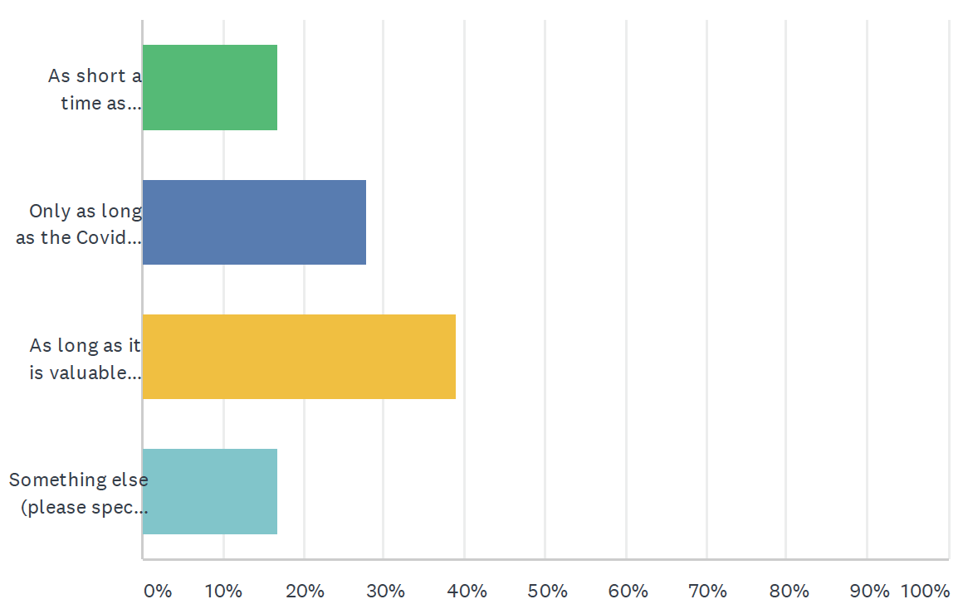
When voting on this question in the online questionnaire, we were each asked to give a brief reason for our answer. Reasons will be analysed and reported in the Juries’ Report in June.

Q2b: By whom should these decisions be made?

Answer choices | Responses | Percentage
An independent advisory group of experts and lay people | 8 | 44%
The minister or organisation accountable for the data initiative | 2 | 11%
Parliament | 2 | 11%
Someone else | 6 | 33%
TOTAL *(% may not equal 100 due to rounding) | 18 | 100%*

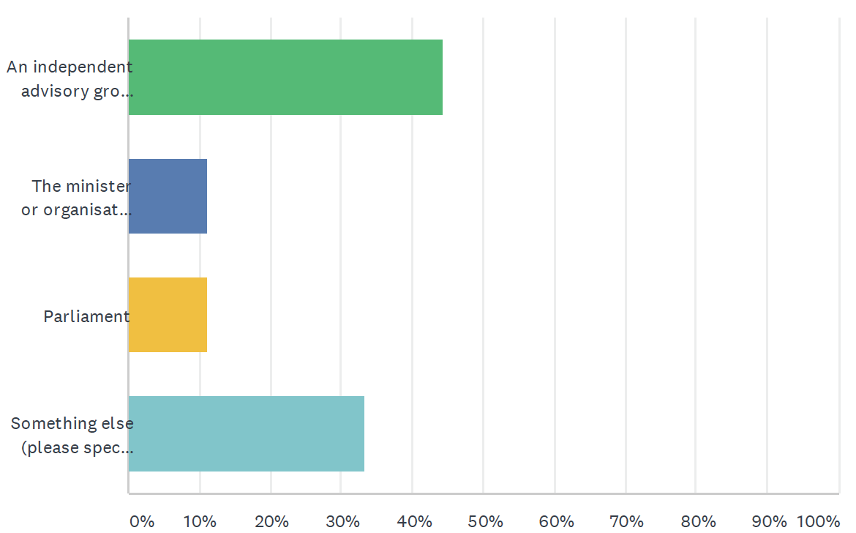

When voting on this question in the online questionnaire, we were each asked to give a brief reason for our answer. Reasons will be analysed and reported in the Juries’ Report in June.

We were also two further questions about the future of the data sharing initiative:
- What actions, if any, could be taken to engender greater public trust in the initiative? (Q2c)
- How could or should the initiative and its uses be usefully changed in the future (if at all)? (Q2d)
We worked together in groups to identify and prioritise our answers and reasoning to these questions. Our answers and most important reasons for those answers are set out in the two tables below.

Data Store and Platform - Engender Public Trust
In order to engender greater public trust, detailed outline as to how the public will be informed of if/when their personal data has been been accessed outside of the intended use for their direct care, the origin of the request and for what purpose, with a straightforward and easily accessible portal from which members of the public can register their decision to opt-out.
There should be a greater level of transparency about the initiative and what is being done with the data and how and why it is being used (including information on opt-out) which should involve informing the public about the Data Store and Platform via a more appropriate platform than a single blog post (ex. establish a government gateway, send out letters to the public, share information through television or newspapers).
Use a well-known brand to build platforms other than ones that seem to have bad reputations.
The CDSP and all initiatives should incorporate a ‘Public Relations’ specialist into the team, whose sole responsibility is to inform the public of all relevant information.
Staff (who are leading on this initiative) should publicly state that the system is fit for purpose. If they don’t, why should the public feel differently and endorse it?
The Data Platform could engender public trust by publishing the cost savings made by the Data Platform so far in the pandemic.

COVID-19 Data Store and Platform - Future Changes
The public should be informed about the Data Store in a better way as it was mainly announced via a blog post on the NHS website. Moving forward, it needs to be more transparent. People/patients should be made aware that it exists and informed what data is stored and there should be documentation of all applications, deliberations about, and approvals of how data is used).
Have a 2 or 3-tier system for accessing data as opposed to the single front door approach [as outlined in Ming Tang’s presentation].
This data should be audited at the end of the pandemic with a view to moving the software in house’ to limit commercial interests and 3rd party foreign involvement. Software for the project should be sourced from a non-profit source, if possible, as a commercial supplier may have priorities which differ from the NHS.
The Data Store and Platform needs a debate in parliament about its future.
This initiative should seek a new lawful basis for its continuation beyond the pandemic time period (and also for its application to data outside of Covid-19 matters) in order to continue.
In order for the government and public to decide if private companies are really the right fit and have good reputations, put out public tenders for contract work (ideally these are British companies so that we can keep money and work in-house).
The Data Platform could be turned into a Disease Register (as is done for eg Cancer) which would mean proper governance and OpenSAFELY could take on its current role.

Data Sharing Initiative: Early Warning System
The data initiative being considered here is the Early Warning System, a product within the Covid-19 NHS Data Store and Platform "ecosystem". It uses data from the Data Platform to make forecasts about demands on the NHS in England. This is one of two sub-case studies we considered (the other being the Immunisation and Vaccination Management Capability – see section 2.4). For these sub-case studies, we had just two questions to answer: 1a and 2a.

Q1a How supportive are you of the decision to introduce this data sharing initiative in 2020 as part of tackling the COVID-19 outbreak?

Answer choices | Responses | Percentage
Very much in support | 10 | 56%
Broadly supportive | 4 | 22%
Neutral | 1 | 5.5%
Broadly opposed | 2 | 11%
Very much opposed | 1 | 5.5%
TOTAL | 18 | 100%

We each answered the above question along with an individual brief reason for our answer using an online questionnaire. Those free-text reasons will be analysed and reported in the Juries’ Report in June.

Q2a: For how long should the initiative continue?

Answer choices | Responses | Percentage
As short a time as possible | 0 | 0%
Only as long as the Covid pandemic continues and emergency powers are in place | 3 | 17%
As long as it is valuable (potentially beyond the pandemic and for Covid and non-Covid uses) | 10 | 55%
Something else | 5 | 28%
TOTAL | 18 | 100%

When voting on this question in the online questionnaire, we were each asked to give a brief reason for our answer. Reasons will be analysed and reported in the Juries’ Report in June.

Data Sharing Initiative: Immunisation and Vaccination Management Capability

The data initiative being considered here is the Immunisation and Vaccination Management Capability, a product within the Covid-19 NHS Data Store and Platform "ecosystem". It uses data from the Data Platform to help manage the implementation of vaccines in England. This is the second of the two sub-case studies we considered (the other being the Early Warning System – see section 2.3). For these sub-case studies, we had just two questions to answer: 1a and 2a.

Q1a How supportive are you of the decision to introduce this data sharing initiative in 2020 as part of tackling the COVID-19 outbreak?

Answer choices | Responses | Percentage
Very much in support | 14 | 78%
Broadly supportive | 2 | 11%
Neutral | 0 | 0%
Broadly opposed | 2 | 11%
Very much opposed | 0 | 0%
TOTAL | 18 | 100%

We each answered the above question along with an individual brief reason for our answer using an online questionnaire. Those free-text reasons will be analysed and reported in the Juries’ Report in June.

Q2a: For how long should the initiative continue?

Answer choices | Responses | Percentage
As short a time as possible | 0 | 0%
Only as long as the Covid pandemic continues and emergency powers are in place | 2 | 11%
As long as it is valuable (potentially beyond the pandemic and for Covid and non-Covid uses) | 12 | 67%
Something else | 4 | 22%
TOTAL | 18 | 100%

When voting on this question in the online questionnaire, we were each asked to give a brief reason for our answer. Reasons will be analysed and reported in the Juries’ Report in June.

Data Sharing Initiative: OpenSAFELY and its access to GP data

The data initiative being considered here is the software OpenSAFELY and specifically the access it currently provides to general practice (GP) data for research purposes. Researchers write and software queries to extract anonymised data directly from the GP patient electronic records. The legal basis for this data sharing initiative, and specifically for the access it is granted to GP electronic records, were the temporary provisions in the COPI Notices issued in 2020 (and subsequently renewed until September 2021).

Question 1 asks how supportive we were of the decision to introduce the data sharing initiative in Spring 2020. We voted on the multiple choice question (Q1a).

Q1 How supportive are you of the decision to introduce this data sharing initiative in 2020 as part of tackling the COVID-19 outbreak?

Answer choices | Responses | Percentage
Very much in support | 16 | 89%
Broadly supportive | 2 | 11%
Neutral | 0 | 0%
Broadly opposed | 0 | 0%
Very much opposed | 0 | 0%
TOTAL | 18 | 100%

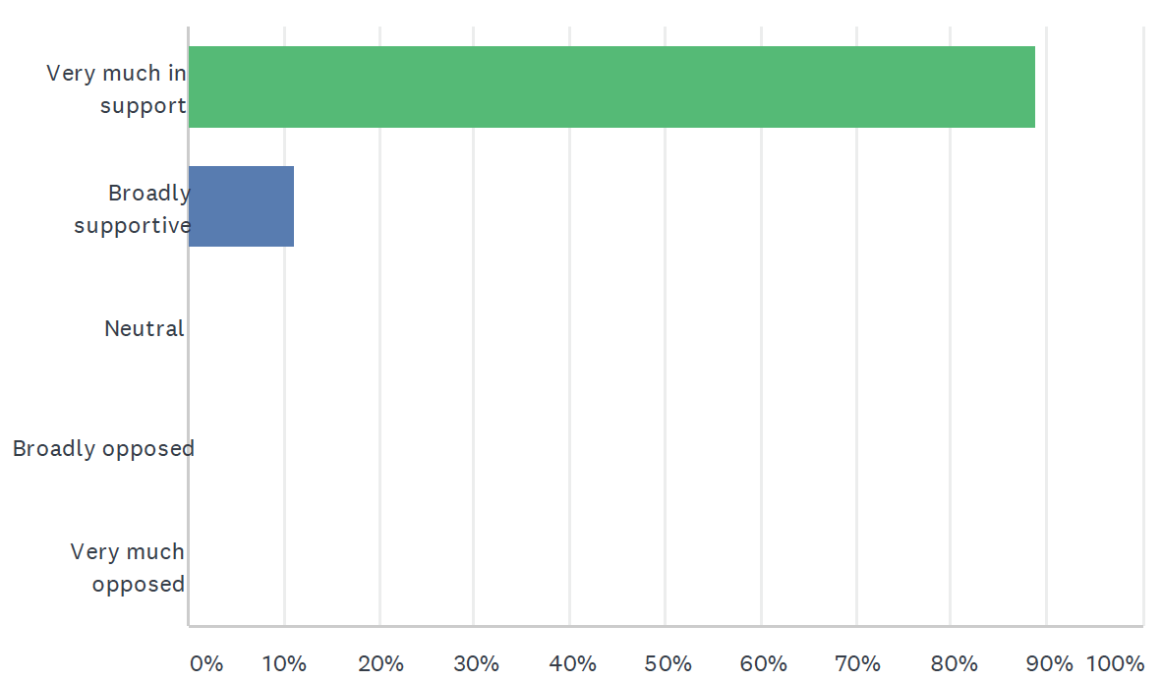

We also identified and prioritised our reasons to support (Q1b) and oppose (Q1c) the data sharing initiative.

Reasons to Support - OpenSAFELY
It is a software platform that doesn’t require the moving or downloading of data, so data cannot be edited or copied and researchers do not need to access the data in order to analyze it, ensuring confidentiality and minimising usage of sensitive information and maximising safety and security. - 17 votes
Its data operation has been well-documented in the public domain, public concerns have been considered, opt out information is provided (where applicable), and most of the “Five Safes” of the ONS are met. - 12 votes
The data has had a critical impact on our response to the pandemic (ex. used to conduct research that has directly influenced the critical response to the current pandemic especially with the vaccination programme). - 9 votes
A reason to support OpenSAFELY is that it comes from an academic base, rather than a commercial base, so it is independent of future commercial pressures. - 7 votes
Open Safely has been built by a group from Oxford University and is not related to the Data Store and Platform, which owes its origin to commercial interest companies such as Palantir and Microsoft. - 4 votes
OpenSAFELY analytics are gathered in near real time, making its results extremely valuable and useful. - 4 votes
OpenSAFELY has been helping the NHS do what NHS Digital has been unable to do on its own and has the support of the Medical Director. - 1 vote

Reasons to Oppose - OpenSAFELY
There is not clarity about the future of the initiative (eg when it may run out of funding, what changes may be in store for the future, its uses post-COVID). - 13 votes
At present, OpenSafely does not have a legitimate lawful basis to extend the work they are currently doing beyond the pandemic period and its applicability does not at present include non-covid related matters. - 12 votes
OpenSAFELY only covers the GP records and not the bigger picture (ie PPE supply). - 7 votes
They do not respect the National Data Opt Out (NDOP), since patients were unaware about this initiative at its onset and they do not make people aware of their choice to opt out of this. - 4 votes
A reason to oppose the initiative is that it involves the handling of 58 million patient records which may come with its own independent risks. - 2 votes
It is an unnecessary initiative as the NHS is already collecting and sharing medical data and while extensive data considerations are in place, OpenSafely is not directly involved in our care. - 1 vote
Those with a commercial interest in NHS data might have an interest in opposing this initiative. - 1 vote
There has been low transparency to the public about it’s legal background, regarding what jurisdiction and the exact rules it follows under law. - 0 votes

Q2 What should the future of the data sharing initiative be?

We heard arguments from witnesses and then voted on two multiple choice questions about what we believe should be the future of the access provided to GP records by OpenSAFELY.

Q2a: For how long should the initiative continue?

Answer choices | Responses | Percentage
As short a time as possible | 0 | 0%
Only as long as the Covid pandemic continues and emergency powers are in place | 0 | 0%
As long as it is valuable (potentially beyond the pandemic and for Covid and non-Covid uses) | 14 | 78%
Something else | 4 | 22%
TOTAL | 18 | 100%

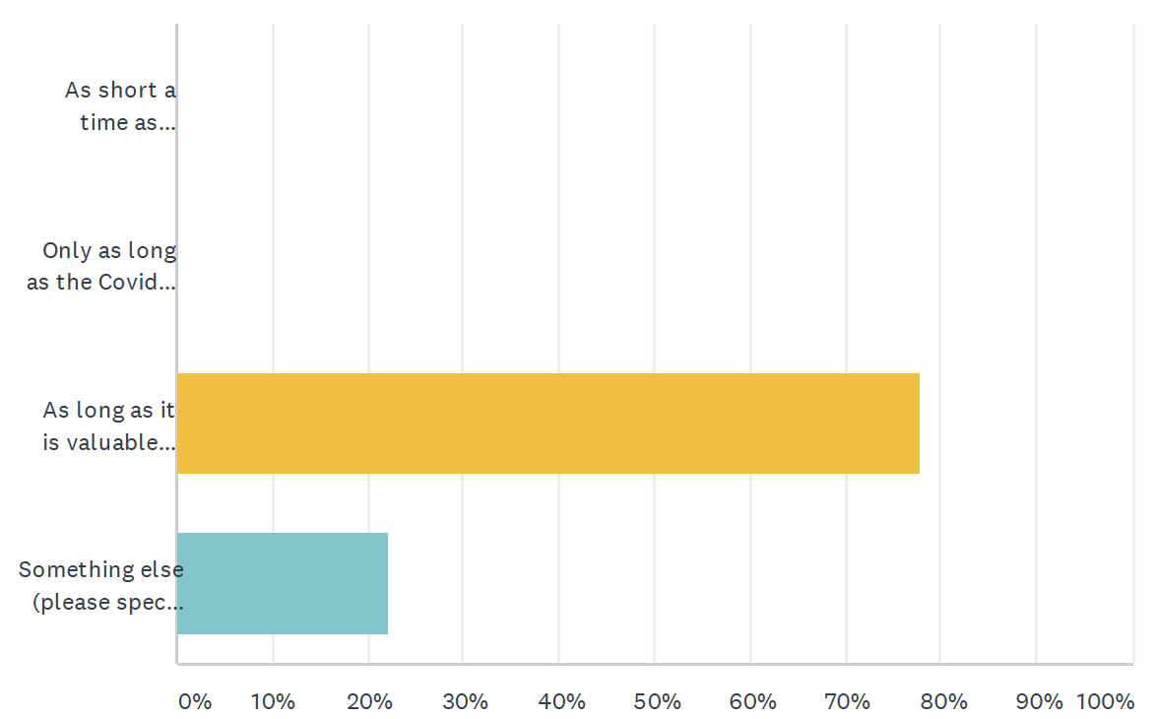

When voting on this question in the online questionnaire, we were each asked to give a brief reason for our answer. Reasons will be analysed and reported in the Juries’ Report in June.

Q2b: By whom should these decisions be made?

Answer choices | Responses | Percentage
An independent advisory group of experts and lay people | 3 | 17%
The minister or organisation accountable for the data initiative | 4 | 22%
Parliament | 3 | 17%
Someone else | 8 | 44%
TOTAL | 18 | 100%

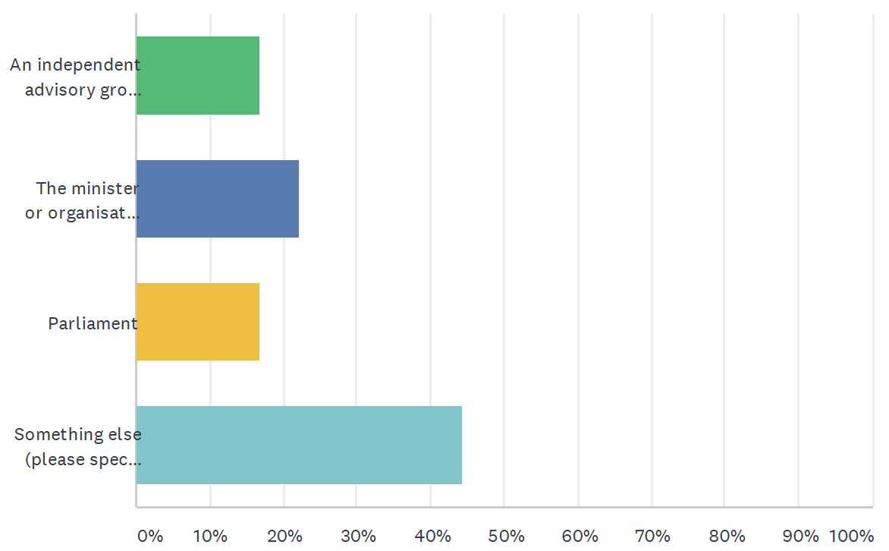

When voting on this question in the online questionnaire, we were each asked to give a brief reason for our answer. Reasons will be analysed and reported in the Juries’ Report in June.

We were also two further questions about the future of the data sharing initiative:
- What actions, if any, could be taken to engender greater public trust in the initiative? (Q2c)
- How could or should the initiative and its uses be usefully changed in the future (if at all)? (Q2d)
We worked together in groups to identify and prioritise our answers and reasoning to these questions. Our answers and most important reasons for those answers are set out in the two tables below.

OpenSAFELY - Engender Public Trust
Because OpenSAFELY draws from GP patient records (the data is not copied but rather skimmed by SQL query to get summary data) the public should be informed about how the initiative is using, and wants to use, their data for research, and be given the opportunity to opt out.
There should be a full review and strategic decision plan about OpenSAFELY’s future-usage, post-pandemic.
OpenSAFELY should communicate about its requirements and laws under which it operates for using data for research.
We were told that OpenSafely had created an “oversight team” to which academics had been invited. This invitation also could be extended to non-academics, such as a selected group from the general public, similar to “Citizens’ Juries.”
Reiterate to the public that this is currently an entirely separate initiative (ie. it is separate from the data store), but it may change at some point in the future.
Highlight the fact that OpenSafely is an initiative started by researchers and academics for the purpose of helping with planning during the pandemic, and explain that it has not elicited direct involvement from commercial organisations in interpreting the results.
OpenSAFELYshould come under NHS Digital and thus will have to comply with their Information Governance processes.

OpenSAFELY - Future Changes
OpenSAFELY should be more transparent in informing patients about their data use and providing an opportunity to opt out of its inclusion in the dataset; patients must be able to decide if they want their data to be used for purposes beyond their direct care.
Once an access application has been granted to external research organisations, OpenSAFELY should make these audit trails available in the public domain.
In the future, after Covid, OpenSAFELY could be possibly applied to totally unrelated phenomena, ie: unsocial behavior & social unrest. Could this system of data collection be utilized in identifying problem areas, in order to try and find solutions?
OpenSAFELY could serve as a “best practice” model for how other data initiatives are structured and governed in the future (eg, not duplicating, moving, or copying data, using an external oversight group, communicating effectively with the public and emphasizing transparency in how data is used and by whom).
This initiative needs a new legal footing to continue post-pandemic. There needs to be clarity on OS’s lawful basis beyond the COPI notices to ensure correct governance. A possible solution would be to incorporate OS into NHS Digital because it is a statutory safe haven.
OpenSAFELY could secure additional ongoing funding, including funds from the government, which would demonstrate the quality of the platform and its credibility.
Assist the NHS in creating its own data platform and data store, or become part of the NHS, therefore not needing as much interaction from other companies to be involved.

After considering each data sharing initiative, we were asked to consider a final question:

Q3 What lessons could be learned for the future?

The first part of the question concerned lessons for future pandemics and the second part was around lessons learned which could be useful outside of pandemics. We worked together in groups to identify and prioritise our answers and reasoning to these questions.

Lessons for Future Pandemics
It will be important to not misuse or manipulate emergency powers under the guise of public interest and be mindful of transparency, fairness, the public’s wants and wishes and to articulate why data is being used and how from the outset, regardless of convenience for political decisions or approaches.
The initiatives were introduced at speed due to the pandemic so going forward with the systems in place we should ensure that these initiatives are kept up to date technologically so that we are ready for the next pandemic.
People must be informed of what is happening and the government should have a greater level of transparency about what these initiatives are and how they are being used - the public should be made aware of how and why their medical records are being used and their rights to opt out.
One important lesson that is important for future pandemics is that although new initiatives are important, if introduced without transparency they may lose their value and affect the trust of the public toward the NHS and Government.
The creators of OpenSafely took the initiative, as an already established and functioning team, to offer their services to the NHS. I find this admirable and I think that other ‘already established teams of academics’ should do likewise, in the event of any future pandemic or national emergency.

Lessons for Future Outside Pandemics
One lesson for the future is about the importance of maintaining transparency in garnering public trust about an initiative (eg, if you have nothing to hide then don’t hide it and broadcast your intentions and reasonings so the public can support it).
Data initiatives such as OpenSafely (which provides real time information, reports, and analysis from vast amounts of data without having to access or download the data itself) have enormous potential for the public good using centralised GP records, without copying or moving data or endangering individual privacy.
It is possible that a more centralised system in the NHS which includes summary care records with additional information plus social care records would be more beneficial to health professionals across the board.
These initiatives could be used outside of the pandemic as they have led to much better systems of data in place that allow for more efficient and faster sharing of data for treatments and healthcare that could be valuable in other areas of healthcare (for example treatments and research for instance cancer and diabetes research, heart research, etc.,).
Reviewing and revising current systems/initiatives put in place, assessing if data management systems could be useful in non pandemic situations, and ensuring that relevant organising are adhering to the GDPR regulations are all important considerations for future data initiatives.
An important lesson that we can learn that will be useful outside of pandemics is that transparency and good communication with the public is key to introducing new data initiatives, especially when the data of people are going to be used.

The jury process: what we heard and did

This section provides an overview of what we did over the eight days of the citizens’ jury: from 13.00 to 17.30 each day on 16-19 March, and then from 22-25 March 2021. We heard from a range of expert witnesses. We asked questions and collectively captured important information after each presentation. The briefs given to each presenter and their slides will be published online when the set of three citizens’ juries are complete.

Jury Day 1: Context setting

The event began with introductions by jury members, and to the citizens’ jury process and deliberation. This was led by the process designers and facilitators Kyle Bozentko and Sarah Atwood from the Center for New Democratic Processes (formerly Jefferson Center).

We then heard from Dr Alan Hassey, a former GP and health informatician. He was briefed to address the question: “what are patient and care records and how are they used?”.

Jury Day 2: Background information

Peter Singleton, a consultant specialising in health information governance, began the day with a presentation addressing the question: “what are the normal rules for using and protecting patient records?”.

Peter Singleton then gave a second presentation addressing the question: “How did the normal rules change for the pandemic?”.

The final presentation was from Prof David Harper, Senior Consulting Fellow at Chatham House. He was briefed to present on: “planning for pandemics”.

Jury Day 3: Summary Care Record Additional Information

Day 3 was devoted to this data sharing initiative. The first presentation was delivered jointly by Dr Robert Jeeves, GP Lead for Summary Care Record, NHS Digital (neutral content) and John Farenden, Senior Programme Lead, Shared Records Programme, NHSX (persuasive content).

Phil Booth, medConfidential co-ordinator, was briefed to raise concerns and challenges about the data sharing initiative.

Jury Day 4: NHS Covid-19 Data Store and Platform

Day 4 was devoted to this data sharing initiative. The first presentation (both neutral and persuasive content) was delivered by Ming Tang, National Director Data and Analytics at NHS England and NHS Improvement.

Phil Booth, medConfidential co-ordinator, was briefed to raise concerns and challenges about the data sharing initiative.

Jury Day 5: Early Warning System and Immunisation and Vaccination Management Capability

On Day 5 we considered two sub-case studies: firstly, the Early Warning System and then the Immunisation and Vaccination Management Capability. These two data sharing initiatives are products within the NHS Covid-19 Data Store and Platform “ecosystem”.

The first Early Warning System presentation was delivered jointly by Ed Kendall, Deputy Director for Economics (neutral content) and Dr Harrison Carter, National Medical Director’s Clinical Fellow (persuasive content), both from NHS England and NHS Improvement.

Phil Booth, medConfidential co-ordinator, was briefed to raise concerns and challenges about the Early Warning System data sharing initiative.

The first Immunisation and Vaccination Management Capability presentation was delivered by Ayub Bhayat, Director of Insights and Data Platform Capability from NHS England and NHS Improvement.

Phil Booth, medConfidential co-ordinator, was briefed to raise concerns and challenges about the Immunisation and Vaccination Management Capability data sharing initiative.

Jury Day 6: OpenSAFELY

Day 6 was devoted to this data sharing initiative. The first presentation (both neutral and persuasive content) was delivered by Jess Morley, Policy Lead, University of Oxford’s DataLab.

Phil Booth, medConfidential co-ordinator, was briefed to raise concerns and challenges about the data sharing initiative.

Jury Day 7: Jury Deliberations

On day 7, we worked together to further develop our thinking about the data sharing initiatives, and lessons learned for the future.

Jury Day 8: Deliberation and report writing (this report)

On the final jury day, we had further deliberations, voted on jury questions, and worked on and agreed the contents of this report.

Appendix A: The jury questions

The three citizens’ juries all consider the same set of questions.

The juries will consider three pandemic data initiatives which were introduced or substantially changed in response to Covid-19::
- Summary Care Record (which was extended to include more data about patients during the pandemic)
- NHS Covid-19 Data Store (which was created in response to the pandemic)
- OpenSAFELY (which uses primary care data for research).

For each initiative, the jury will address the following questions:

- a) How supportive are you of the decision to introduce this data sharing initiative in 2020 as part of tackling the COVID-19 outbreak?
Very much in support/ Broadly supportive/ Neutral/ Broadly opposed/ Very much opposed

- “What are the most important reasons to be supportive?”
- “What are the most important reasons to oppose the initiative?”

- What should the future of the data sharing initiative be?
  - For how long should the initiative continue
    - As short a time as possible
    - Only as long as the Covid pandemic continues and emergency powers are in place
    - As long as it is valuable (potentially beyond the pandemic and for Covid and non-Covid uses)
    - Something else

  - By whom should these decisions be made?
    - An independent advisory group of experts and lay people
    - The minister or organisation accountable for the data initiative
    - Parliament
    - Someone else

  - How could or should the initiative and its uses be usefully changed in the future (if at all)?
  - What actions, if any, could be taken to engender greater public trust in the initiative?
  - What are the main reasons for these answers?

At the end of each jury, the jury will be asked:
- What lessons can we learn from how these pandemic data initiatives were introduced
  - which could be useful for future pandemics?
  - which could be useful outside of pandemics?

There are also two “sub-case studies” for the jury to consider. These are systems reliant on the NHS Covid-19 Data Store:
- The Early Warning System
- The Immunisation and Vaccination Management (I&V) Capability.

The juries will answer two of the above questions about each of these sub-case studies: 1 a) and 2a).

Emergency powers are in place to deal with the pandemic, see: https://www.instituteforgovernment.org.uk/explainers/emergency-powers

